CYBERSECURITY THREAT INTELLIGENCE AGENT

Abstract
Cybersecurity Threat Intelligence has become an essential component of modern security operations because organizations continuously face malware, phishing, ransomware, vulnerabilities, malicious domains, suspicious URLs, and other cyber threats. The proposed Cybersecurity Threat Intelligence Agent is an AI-assisted platform designed to collect, process, analyze, and present cyber threat information in a structured and actionable form. The system integrates RSS-based threat intelligence collection, Indicator of Compromise (IOC) extraction, threat classification, severity assessment, and MITRE ATT&CK technique mapping into a unified workflow. A Gemini-based artificial intelligence component is incorporated to provide deeper analysis and generate structured threat intelligence from collected reports. The platform also provides an AI chatbot through which users can interact with the collected threat information and obtain analytical responses. A rule-based fallback mechanism allows the system to continue functioning when external AI services or Internet connectivity are unavailable. The proposed system uses React and Vite for the frontend, Python FastAPI for the backend, and SQLite3 for local data storage. It provides separate User and Administrator modules for threat analysis, file uploads, configuration, user management, RSS ingestion, and historical activity analysis. The system is therefore intended to support cybersecurity analysts, security operations teams, researchers, and students in transforming unstructured threat reports into meaningful and actionable cybersecurity intelligence.

Chapter 1: Introduction

1.1 Introduction
Cybersecurity has evolved into a critical area of information technology because modern organizations depend extensively on interconnected networks, cloud platforms, web applications, databases, endpoint systems, and digital communication infrastructure. This increased connectivity has also created a larger attack surface for cybercriminals and threat actors. Security teams continuously encounter different categories of threats, including malware, phishing campaigns, ransomware, exploitation of vulnerabilities, malicious websites, suspicious domains, and other forms of cyber attacks. Consequently, security professionals require timely and reliable Cybersecurity Threat Intelligence to understand emerging threats, identify Indicators of Compromise, determine their potential impact, and take appropriate defensive measures. The Cybersecurity Threat Intelligence Agent proposed in this project is designed as an AI-assisted platform for automating several important activities involved in threat intelligence processing. According to the project architecture, the platform combines RSS-based threat intelligence collection with an IOC engine, threat classification, severity calculation, MITRE ATT&CK mapping, and Gemini-based AI analysis. The system collects threat-related articles from configured RSS sources and processes newly collected information through the IOC and threat-analysis pipeline. Extracted indicators can include information useful for identifying potentially malicious infrastructure or activities. The system then classifies the identified threat, evaluates its severity, and associates relevant activities with MITRE ATT&CK techniques. An AI analysis component further enhances the interpretation of collected information by generating structured threat analysis. The platform additionally provides an AI chatbot, file-upload functionality, dashboards, authentication, and administrative controls. The application follows a full-stack architecture consisting of React and Vite on the frontend, Python FastAPI on the backend, and SQLite3 for database storage. This architecture provides a centralized environment in which threat information can be collected, analyzed, stored, searched, and presented to authorized users. The system can also operate with seeded sample intelligence and a local rule-based analysis engine, allowing the platform to demonstrate its core functionality without requiring external API connectivity.

1.2 Problem Statement
The rapid growth of cyber attacks has created a significant challenge for organizations that must continuously monitor and analyze large quantities of security-related information. Cybersecurity threat reports are frequently distributed through different sources, including security advisories, threat research publications, RSS feeds, and other intelligence channels. Manually reviewing these reports and identifying useful security indicators can consume substantial time and effort for cybersecurity analysts. The problem becomes more complicated when threat information is presented as unstructured textual content rather than as standardized intelligence. Analysts may need to identify potentially malicious IP addresses, domains, URLs, hashes, and other Indicators of Compromise from reports before determining the associated threat category and severity. They may then need to investigate the observed behavior and relate it to appropriate MITRE ATT&CK techniques. Performing these activities manually can introduce delays and inconsistencies, particularly when security teams are dealing with a large volume of continuously changing threat information. The proposed Cybersecurity Threat Intelligence Agent addresses this problem by providing an integrated platform for collecting and processing threat intelligence through an automated pipeline. The uploaded project specification identifies dedicated services for IOC extraction, threat classification, severity calculation, MITRE mapping, RSS collection, and Gemini-based threat analysis. Another challenge is the dependence of some intelligent cybersecurity systems on external AI services and Internet connectivity. To address this requirement, the proposed platform includes a rule-based fallback analysis mechanism and seeded sample threat articles so that core functions remain demonstrable even when external services are unavailable. The system also addresses the need for controlled access and operational management by providing separate user and administrator capabilities. Users can perform threat searches, detection, AI chatbot interactions, and file uploads, while administrators can manage users, configure API integration, manage RSS feeds, initiate ingestion, and analyze historical activity. Therefore, the central problem addressed by this project is the development of an integrated, automated, and AI-assisted environment capable of converting raw cybersecurity threat information into structured and actionable intelligence while maintaining practical usability and offline demonstration capability.

1.3 Research Motivation
The primary motivation for developing the Cybersecurity Threat Intelligence Agent originates from the increasing complexity, frequency, and diversity of cyber threats and the resulting requirement for faster security analysis. Traditional threat intelligence workflows can require analysts to manually collect information from multiple sources, inspect lengthy reports, identify relevant Indicators of Compromise, classify threats, estimate their severity, and investigate associated attack techniques. Such activities can become difficult to manage when the volume of threat information increases. An automated intelligence-processing framework can reduce repetitive analytical work and help security professionals focus on investigation and response. The proposed project is particularly motivated by the opportunity to combine conventional cybersecurity techniques with artificial intelligence. The system does not depend exclusively on an AI model; instead, it combines deterministic IOC extraction and threat-analysis functions with Gemini-based AI analysis. This hybrid approach is significant because structured security processing can be performed through predefined analytical logic while AI can be used to interpret threat information and generate additional analytical insights. The project specification states that the Gemini service uses the threat-analysis prompt from the original notebook and includes a deterministic fallback analyzer so that the application remains demonstrable without an API key or Internet connection. Another motivation is the need to connect threat information with a recognized cybersecurity knowledge framework. MITRE ATT&CK mapping can provide a structured representation of adversarial techniques associated with observed threats, making the collected information more useful for security analysis and defensive planning. The system is also motivated by the need for centralized access to threat intelligence through a practical web application rather than limiting the implementation to a research notebook. The resulting architecture provides dedicated user and administrator interfaces, dashboards, threat-search functionality, an AI chatbot, file uploads, API configuration, RSS ingestion, and activity history. From a research and educational perspective, the project also demonstrates how artificial intelligence, cybersecurity analytics, web technologies, threat feeds, structured IOC processing, and security frameworks can be integrated into a single application. Therefore, the research motivation is to develop a practical and extensible threat-intelligence platform that improves the organization, automation, and interpretation of cybersecurity information while demonstrating the role of AI in modern security operations.

1.4 Applications
The Cybersecurity Threat Intelligence Agent can be applied across several cybersecurity and information-security scenarios where continuous collection and analysis of threat information are required. One important application is Security Operations Center (SOC) support, where analysts continuously investigate security events and require contextual information about emerging threats, malicious infrastructure, and known attack techniques. By collecting threat reports and automatically extracting indicators, classifying threats, calculating severity, and mapping activities to MITRE ATT&CK techniques, the platform can assist analysts in organizing intelligence for further investigation. Another application is threat hunting, where security professionals search for indicators that may exist within organizational systems and compare them with information obtained from external threat intelligence sources. The IOC extraction functionality can support this process by identifying potentially relevant indicators from collected reports. The platform can also be used for cybersecurity research and education, allowing students and researchers to understand the complete lifecycle of threat intelligence, from data collection through automated analysis and presentation. The AI chatbot provides an additional interactive mechanism for exploring threat information, while the seeded sample intelligence enables demonstrations without requiring continuous external connectivity. Another application is threat-feed monitoring, where administrators configure RSS sources and initiate ingestion to collect new threat-related articles. The project specification states that newly collected articles can be processed through the IOC, severity, and MITRE pipeline. The system can also support security incident investigation by helping analysts organize relevant threat information and associate observed indicators with threat categories and attack techniques. Enterprise security teams can use the administrative functionality for managing users, configuring AI integration, maintaining threat sources, and reviewing historical activity. Cybersecurity training programs can use the application as a practical laboratory environment for demonstrating IOC extraction, threat classification, severity analysis, MITRE ATT&CK mapping, and AI-assisted cybersecurity analysis. Finally, the platform can serve as a foundation for future extensions such as additional threat feeds, advanced analytics, automated alerting, richer threat correlation, and integration with other security infrastructure. Its modular architecture, consisting of dedicated backend services and routers for authentication, threats, administration, chatbot functionality, uploads, and dashboard statistics, supports these potential extensions.

CHAPTER 2: LITERATURE SURVEY

2.1 N. Sun et al., “Cyber Threat Intelligence Mining for Proactive Cybersecurity Defense: A Survey and New Perspectives,” IEEE Communications Surveys & Tutorials, 2023
Sun et al. presented a comprehensive survey of Cyber Threat Intelligence mining techniques and their role in proactive cybersecurity defense. The authors observed that modern cyber attacks are increasingly sophisticated, evasive, and complex, making conventional signature- and heuristic-based security mechanisms insufficient for many emerging threats. The study explains how CTI mining transforms large volumes of cybersecurity-related information into useful intelligence that can support security decision-making. The authors categorize CTI mining into areas such as cybersecurity entity and event extraction, threat intelligence discovery, IOC extraction, TTP identification, and other forms of knowledge acquisition. Of particular relevance to the proposed system is the discussion of extracting IP addresses, domains, hashes, vulnerabilities, and other IOCs from unstructured threat reports. The survey also highlights the importance of NLP, machine learning, information retrieval, and knowledge representation in CTI processing. It emphasizes that extracted intelligence can support threat hunting, cybersecurity search engines, education, and proactive defense. The study therefore establishes a strong theoretical foundation for automatically collecting and processing threat reports. The proposed Cybersecurity Threat Intelligence Agent extends these concepts through RSS collection, IOC extraction, threat classification, severity calculation, and MITRE ATT&CK mapping.

2.2 V. Mavroeidis and S. Bromander, “Cyber Threat Intelligence Model: An Evaluation of Taxonomies, Sharing Standards, and Ontologies within Cyber Threat Intelligence,” 2017
Mavroeidis and Bromander investigated the conceptual structure of Cyber Threat Intelligence by evaluating taxonomies, information-sharing standards, and ontologies used within the CTI domain. Their research is important because effective threat intelligence requires consistent representation of cybersecurity concepts and relationships. The study examines how different CTI models can organize information concerning threats, actors, attacks, vulnerabilities, indicators, and other security entities. Standardized representation is essential when intelligence is collected from multiple sources because different sources may describe similar threats using different terminology. The research provides a foundation for understanding why structured threat models are necessary for interoperability and automated analysis. This is directly relevant to the proposed Cybersecurity Threat Intelligence Agent because the system transforms unstructured threat reports into structured information through IOC extraction, threat classification, severity assessment, and MITRE ATT&CK mapping. The use of structured threat categories can improve consistency when analyzing multiple intelligence sources. The study also supports the concept of representing threat intelligence using formal relationships rather than treating each report as isolated textual information. Consequently, this research provides the conceptual basis for organizing the information generated by the proposed platform.

2.3 V. Mavroeidis et al., “Threat Actor Type Inference and Characterization within Cyber Threat Intelligence,” 2021
Mavroeidis and his co-authors focused on identifying and characterizing different types of threat actors using Cyber Threat Intelligence. Threat actors represent an important component of CTI because understanding who is conducting an attack can provide valuable context for determining potential objectives, capabilities, and behaviors. The study investigates the inference of threat-actor types from available intelligence and demonstrates the importance of contextual analysis rather than merely identifying individual indicators. Such characterization can assist security analysts in understanding broader attack campaigns and connecting individual events with known adversarial behavior. The work is relevant to automated threat-intelligence systems because threat reports frequently contain information about attacker groups, malware families, campaigns, and targeted organizations. Extracting and correlating these entities can produce richer intelligence than simple IOC detection. For the proposed system, the study suggests a potential extension beyond basic IP, domain, URL, and hash extraction toward threat-actor profiling. Integrating threat-actor information with MITRE ATT&CK techniques could provide additional context about adversarial behavior. Therefore, this research demonstrates the value of contextual threat intelligence and provides a direction for improving the analytical capabilities of the proposed Cybersecurity Threat Intelligence Agent.

2.4 P. Zhang, J. Ya, T. Liu, and J. Shi, “Mining Open-Source Cyber Threat Intelligence with Distant Supervision from the Web,” 2021
Zhang et al. investigated the extraction of Cyber Threat Intelligence from open-source information available on the Web using distant supervision. Open-source CTI provides a large and continuously changing source of information about vulnerabilities, malware, attacks, campaigns, indicators, and threat actors. However, extracting useful intelligence from Web content is challenging because the information is usually unstructured and contains significant amounts of irrelevant material. The research demonstrates how automated techniques can be applied to transform Web-based information into structured cybersecurity knowledge. Distant supervision is particularly useful because manually labeling large quantities of CTI data can be expensive and time-consuming. The approach therefore provides an important direction for scalable CTI dataset creation and automated intelligence extraction. This research is closely related to the proposed system's RSS-based threat collection module, where threat articles are automatically acquired from configured sources. Once collected, the articles can be passed through an automated processing pipeline to identify IOCs and classify threats. The research also indicates the potential for expanding the proposed system from RSS sources to broader Web-based intelligence collection. Thus, this study supports the automation of CTI acquisition and demonstrates the importance of processing open-source cybersecurity information.

2.5 S. Wolf et al., “Data Collection and Exploratory Analysis for Cyber Threat Intelligence Machine Learning Processes,” 2022
Wolf et al. examined data collection and exploratory analysis as important stages in machine-learning-based Cyber Threat Intelligence processing. The quality and structure of training data significantly influence the performance of machine-learning systems, and CTI datasets often contain heterogeneous information originating from different sources. The study emphasizes the importance of understanding collected cybersecurity data before applying machine-learning techniques. Data preprocessing, exploratory analysis, feature identification, and data-quality assessment can help ensure that subsequent analytical models produce meaningful results. This is relevant to the proposed Cybersecurity Threat Intelligence Agent because threat articles collected from different RSS sources may contain inconsistent structures, terminology, and information density. Before performing AI-based analysis, the collected information needs to be cleaned and converted into an appropriate representation. The study therefore provides methodological support for developing reliable CTI-processing pipelines. Its emphasis on data collection is also relevant when the proposed system is extended with additional threat feeds. Furthermore, the research demonstrates that machine learning should not be treated as an isolated component but as part of a complete data-processing workflow. The proposed system follows a similar philosophy by integrating collection, preprocessing, IOC extraction, classification, severity analysis, and AI interpretation.

2.6 M. Kadoguchi et al., “Exploring the Dark Web for Cyber Threat Intelligence using Machine Learning,” 2019
Kadoguchi et al. investigated the use of machine learning for extracting Cyber Threat Intelligence from Dark Web sources. Dark Web environments can contain valuable information about cybercriminal activities, malware, stolen credentials, attack services, and emerging threats. However, collecting and analyzing Dark Web information presents significant challenges because the content is highly dynamic, noisy, and difficult to organize. The study demonstrates the potential of machine-learning techniques for discovering useful threat intelligence from such environments. The research illustrates that CTI sources extend beyond conventional security reports and public websites and can include specialized underground communities. Automated processing is therefore important for handling the scale and complexity of such information. Although the proposed Cybersecurity Threat Intelligence Agent primarily focuses on RSS-based threat feeds, the concepts presented in this study can support future integration of additional intelligence sources. Machine-learning-based content classification could also be incorporated to distinguish relevant threat information from unrelated content. The research consequently highlights the broader potential of automated intelligence discovery. It also reinforces the importance of combining data collection with intelligent analysis when building scalable CTI systems.

2.7 E. Nunes et al., “Darknet and Deepnet Mining for Proactive Cybersecurity Threat Intelligence,” 2016
Nunes et al. explored the use of Darknet and Deepnet data for proactive Cybersecurity Threat Intelligence. Their research focuses on extracting useful information from sources that are difficult to access and analyze using conventional security-monitoring approaches. Darknet and Deepnet environments can provide early indications of malicious activities, emerging attack techniques, and cybercriminal operations. The study demonstrates the value of mining unconventional information sources to improve awareness of evolving threats. Proactive intelligence is particularly important because organizations should ideally identify emerging threats before they directly affect their infrastructure. The research therefore supports the principle of collecting intelligence from multiple sources and converting it into actionable information. In relation to the proposed system, the work suggests future expansion beyond RSS feeds to specialized intelligence repositories and underground-source monitoring. Automated extraction and classification can help reduce the manual effort required to analyze large quantities of collected information. The study also reinforces the importance of timely threat intelligence for defensive decision-making. Consequently, it provides background support for developing an automated and proactive CTI platform.

2.8 P. I. Radoglou-Grammatikis et al., “Surveying Cyber Threat Intelligence and Collaboration: A Concise Analysis of Current Landscape and Trends,” 2023
Radoglou-Grammatikis et al. presented a survey of Cyber Threat Intelligence and collaboration, examining the current CTI landscape and emerging trends. The research emphasizes that cybersecurity organizations benefit from sharing threat information and collaborating on the identification and mitigation of cyber threats. Threat intelligence becomes more valuable when information can be collected from multiple sources and correlated to identify broader attack patterns. The study therefore highlights the importance of information-sharing mechanisms and collaborative cybersecurity environments. This perspective is relevant to the proposed Cybersecurity Threat Intelligence Agent because the platform collects information from multiple threat feeds and consolidates it into a centralized repository. The system can potentially provide analysts with a unified view of threats rather than requiring them to independently examine multiple sources. The research also supports future integration with standardized intelligence-sharing formats and external CTI platforms. Such integration could allow the proposed system to participate in broader cybersecurity ecosystems. The study therefore provides important background for designing CTI platforms that are not limited to isolated datasets. It also emphasizes the continuing evolution of threat intelligence practices and the importance of scalable collaboration.

2.9 F. Perrina et al., “AGIR: Automating Cyber Threat Intelligence Reporting with Natural Language Generation,” 2023
Perrina et al. proposed AGIR, an automated Cyber Threat Intelligence reporting system based on Natural Language Generation. The study addresses the problem that CTI analysts spend considerable time preparing structured threat reports from collected intelligence. AGIR aims to automate this reporting process by transforming structured threat information into readable natural-language reports. The authors evaluated the generated reports using measures related to linguistic quality and analyst feedback and reported that the system could reduce report-writing time by more than 40 percent. This research is particularly relevant to the proposed Cybersecurity Threat Intelligence Agent because the proposed system also incorporates AI-generated threat analysis. Rather than requiring analysts to manually interpret every collected article, an AI component can summarize and contextualize important findings. The AGIR study demonstrates the practical value of Natural Language Generation in reducing analyst workload. It also highlights the importance of maintaining factual consistency and avoiding hallucinated information when automatically generating cybersecurity reports. The proposed system can build on this concept by using Gemini to produce structured threat analysis after IOC extraction and severity assessment. Thus, this study provides strong support for AI-assisted CTI interpretation and reporting.

2.10 Y. Liu et al., “CTI-JE: A Joint Extraction Framework of Entities and Relations in Unstructured Cyber Threat Intelligence,” 2024
Liu et al. proposed CTI-JE, a joint extraction framework designed to extract entities and relationships from unstructured Cyber Threat Intelligence. The research addresses a major limitation of conventional information extraction approaches, where entity extraction and relation extraction may be performed independently. In CTI, however, understanding relationships between entities is essential because an IP address, malware family, threat actor, vulnerability, and attack technique may be connected within the same incident. Joint extraction can therefore produce richer intelligence representations. The study demonstrates the growing importance of deep-learning-based NLP methods for transforming unstructured CTI into structured knowledge. This work is highly relevant to the proposed Cybersecurity Threat Intelligence Agent because the system currently focuses on IOC extraction and threat classification and can potentially be extended with relationship extraction. For example, the platform could identify which malware is associated with a domain or which threat actor is associated with a particular attack technique. Such relationships could later be represented through knowledge graphs. The study therefore provides a strong research direction for improving the proposed system's analytical depth.

2.11 H. Lv et al., “Joint Extraction of Entities and Relationships from Cyber Threat Intelligence Based on Task-Specific Fourier Network,” 2024
Lv et al. investigated joint entity and relationship extraction from CTI using a task-specific Fourier Network. The research belongs to the broader area of NLP-based cybersecurity information extraction, where unstructured threat reports must be converted into structured entities and relationships. The proposed approach reflects the increasing use of specialized neural architectures to address the unique characteristics of cybersecurity language. CTI documents frequently contain technical terminology, abbreviations, malware names, vulnerability identifiers, IP addresses, domains, and descriptions of adversarial behavior. General-purpose NLP models may not always capture these relationships effectively, making task-specific modeling important. The study therefore contributes to the development of more sophisticated CTI knowledge-extraction systems. Its concepts can be applied to the proposed Cybersecurity Threat Intelligence Agent as a future enhancement to the existing IOC extraction engine. Instead of identifying individual indicators independently, an advanced model could identify relationships among indicators, malware, actors, vulnerabilities, and attack techniques. This would improve the contextual intelligence generated by the system. Consequently, the study demonstrates how specialized NLP architectures can strengthen automated CTI processing.

2.12 X. Wang et al., “Joint Learning for Document-Level Threat Intelligence Relation Extraction and Coreference Resolution Based on GCN,” 2020
Wang et al. investigated document-level threat-intelligence relation extraction and coreference resolution using a Graph Convolutional Network-based approach. The research recognizes that relationships in cybersecurity reports can extend across multiple sentences and may require contextual interpretation. Coreference resolution is important because a threat actor or malware family may be referred to using different expressions throughout a report. Graph-based approaches can represent relationships among entities and facilitate document-level reasoning. This is relevant to CTI because simply extracting individual entities does not necessarily reveal how those entities interact. The proposed Cybersecurity Threat Intelligence Agent could potentially incorporate graph-based relation analysis to build richer threat representations. For example, multiple IOCs could be linked to the same malware family or campaign. Such relationships could then be correlated with MITRE ATT&CK techniques and threat severity. The research therefore demonstrates the importance of contextual and relational analysis in CTI. It also provides a foundation for future development of a CTI knowledge graph within the proposed system.

2.13 A. Piplai et al., “Creating Cybersecurity Knowledge Graphs From Malware After Action Reports,” IEEE Access, 2020
Piplai et al. investigated the creation of cybersecurity knowledge graphs from malware after-action reports. Knowledge graphs provide a structured mechanism for representing cybersecurity entities and the relationships among them. In threat intelligence, such representations can connect malware, threat actors, vulnerabilities, indicators, attack techniques, and affected systems. The research demonstrates the potential of converting textual cybersecurity reports into machine-readable knowledge structures. This is important because conventional document storage treats reports as isolated pieces of information and makes cross-report reasoning more difficult. A knowledge graph can instead enable analysts to identify connections across multiple reports and campaigns. The proposed Cybersecurity Threat Intelligence Agent could benefit from this approach by storing extracted entities and their relationships in a graph-oriented representation. IOC extraction could serve as the initial stage, followed by relationship identification and graph construction. MITRE ATT&CK techniques could also be integrated as standardized nodes or relationships. Therefore, this research provides a valuable direction for extending the proposed platform from basic threat analysis toward knowledge-driven cybersecurity intelligence.

2.14 K. Shaukat et al., “Cyber Threat Detection Using Machine Learning Techniques: A Performance Evaluation Perspective,” 2020
Shaukat et al. examined machine-learning techniques for cyber-threat detection and evaluated their performance from a comparative perspective. The research demonstrates the importance of applying machine-learning algorithms to cybersecurity data for identifying potentially malicious activities. Different machine-learning methods may exhibit different levels of effectiveness depending on the characteristics of the dataset, features, and detection problem. This highlights the need for appropriate model selection and evaluation rather than assuming that one algorithm is universally optimal. Although the proposed Cybersecurity Threat Intelligence Agent focuses primarily on CTI processing rather than network intrusion detection, the underlying principles are highly relevant. Machine-learning models could be introduced to classify threat articles, predict threat severity, detect anomalous indicators, or prioritize intelligence for analyst review. The research therefore provides methodological support for incorporating machine learning into future versions of the proposed system. It also reinforces the importance of performance evaluation when intelligent cybersecurity components are deployed. Consequently, this work supports the broader AI-driven direction of the proposed CTI platform.

2.15 M. Ozkan-Okay et al., “A Comprehensive Survey: Evaluating the Efficiency of Artificial Intelligence and Machine Learning Techniques on Cyber Security Solutions,” IEEE Access, 2024
Ozkan-Okay et al. provided a comprehensive survey of Artificial Intelligence and Machine Learning techniques applied to cybersecurity solutions. The study examines how AI and ML can be used for various security tasks, including detection, classification, prediction, and analysis. It demonstrates that AI has become increasingly important in addressing cybersecurity problems because of the volume, speed, and complexity of modern security data. The survey is particularly relevant to the proposed Cybersecurity Threat Intelligence Agent because the system integrates AI with conventional cybersecurity processing. AI can assist with interpreting threat reports, classifying threat information, generating analytical summaries, and supporting decision-making. However, the research also highlights the importance of evaluating AI techniques according to their security requirements and application context. This is important for the proposed platform because AI-generated intelligence should complement, rather than blindly replace, deterministic cybersecurity processes. The hybrid architecture combining IOC extraction, severity calculation, MITRE mapping, and Gemini analysis follows this principle. Thus, this survey provides broad academic support for the use of AI and ML in modern cybersecurity systems.

2.16 Z. Guan et al., “When Machine Learning Meets Security Issues: A Survey,” 2018
Guan et al. examined the interaction between machine learning and cybersecurity issues. The study discusses how machine-learning methods can be used to solve security problems while also recognizing that machine-learning systems themselves can introduce security challenges. This dual perspective is important because cybersecurity applications require not only accurate predictions but also robustness and reliability. Machine-learning models can be applied to threat detection, classification, anomaly detection, and other security tasks, but their outputs must be interpreted carefully. The study therefore provides a broader theoretical foundation for incorporating machine learning into cybersecurity applications. In the proposed Cybersecurity Threat Intelligence Agent, AI is used as an analytical assistant rather than as the sole decision-making mechanism. Rule-based IOC extraction and severity assessment can provide deterministic security information, while AI can provide contextual analysis and natural-language explanations. This hybrid approach can help reduce the risks associated with relying entirely on probabilistic AI outputs. The research consequently supports the careful integration of machine intelligence into security workflows.

2.17 M. Kadoguchi et al., “Deep Self-Supervised Clustering of the Dark Web for Cyber Threat Intelligence,” 2020
Kadoguchi et al. proposed a deep self-supervised clustering approach for analyzing Dark Web information in the context of Cyber Threat Intelligence. The research focuses on automatically discovering meaningful groups or patterns within large collections of potentially noisy cybersecurity-related content. Clustering can be valuable when labeled training data are limited, which is a common challenge in cybersecurity. Self-supervised approaches can reduce dependence on manually labeled datasets and help identify previously unknown patterns. The work demonstrates the potential for deep learning to analyze unconventional CTI sources and discover relationships that may not be immediately apparent to analysts. Although the proposed Cybersecurity Threat Intelligence Agent uses RSS feeds as its primary intelligence source, similar clustering techniques could be incorporated in future versions. For example, collected threat articles could be grouped according to malware families, attack campaigns, threat actors, or attack techniques. Such functionality would improve threat discovery and reduce repetitive analyst investigation. The study therefore contributes to the broader research direction of automated and intelligent CTI discovery.

2.18 P. I. Radoglou-Grammatikis et al., “Surveying Cyber Threat Intelligence and Collaboration: A Concise Analysis of Current Landscape and Trends,” 2023
This reference examines the evolving CTI landscape with particular emphasis on collaboration and information sharing. The research demonstrates that cybersecurity intelligence becomes more effective when organizations can exchange information concerning threats, vulnerabilities, attack campaigns, and indicators. Collaborative CTI can provide a broader view of attacks than intelligence generated by an individual organization. The study therefore supports the development of systems capable of collecting information from multiple sources and presenting it through a unified intelligence environment. This concept directly relates to the proposed Cybersecurity Threat Intelligence Agent, which is designed to ingest information from configurable RSS threat feeds and process it through a centralized pipeline. The administrative interface also allows threat-feed configuration and ingestion management. In future implementations, the platform could be extended to support standardized CTI exchange formats and external intelligence-sharing platforms. The study consequently provides support for making the proposed system extensible and interoperable. It also emphasizes the importance of collaboration in developing effective cybersecurity defense capabilities.

2.19 Summary of Literature Survey
The reviewed literature demonstrates a clear progression from manual and source-specific threat analysis toward automated, structured, and AI-assisted Cyber Threat Intelligence processing. Existing research has established methods for CTI mining, IOC extraction, entity and relationship extraction, threat-actor characterization, machine-learning-based detection, knowledge-graph construction, and automated CTI report generation. Sun et al. particularly demonstrate the broad research landscape of CTI mining and emphasize the importance of transforming unstructured cybersecurity information into actionable intelligence. Recent work such as CTI-JE demonstrates the movement toward joint extraction of cybersecurity entities and relationships, while AGIR demonstrates the practical benefits of automated CTI report generation.

CHAPTER 3: EXISTING SYSTEM

3.1 Existing System
The existing Cybersecurity Threat Intelligence environment generally consists of multiple independent tools and information sources that security analysts use to collect, investigate, and interpret cyber threat information. Threat intelligence is commonly obtained from security advisories, cybersecurity research reports, RSS feeds, online threat repositories, vulnerability information, and other publicly available sources. Analysts typically examine these sources manually to identify relevant information about malware, phishing activities, ransomware, vulnerabilities, malicious IP addresses, domains, URLs, hashes, and other Indicators of Compromise. The collected information is then analyzed to determine the nature and potential severity of a threat. In many conventional environments, different activities such as threat-feed monitoring, IOC extraction, threat classification, incident investigation, and attack-technique identification are performed using separate tools or manually maintained processes. This creates a fragmented workflow in which analysts need to move between multiple platforms to obtain a complete understanding of a threat.
Traditional systems may provide individual capabilities such as threat-feed aggregation, IOC lookup, malware analysis, vulnerability monitoring, or security event monitoring, but these capabilities are not necessarily integrated into a single intelligence-processing pipeline. Threat reports may remain in their original unstructured textual format, requiring analysts to manually identify important indicators and contextual information. Similarly, connecting observed activities with standardized attack techniques can require additional investigation. The existing approach therefore depends considerably on analyst expertise and manual interpretation. Some modern security platforms incorporate automation and machine learning, but their functionality may focus on specific detection or monitoring tasks rather than providing an integrated workflow for collecting external threat reports and converting them into structured intelligence.
The source project identifies these conventional requirements and proposes dedicated services for RSS collection, IOC extraction, threat classification, severity calculation, MITRE mapping, and AI-based analysis. Existing approaches also commonly depend on continuous Internet connectivity and external intelligence sources for obtaining current information. Consequently, although existing cybersecurity tools provide valuable capabilities for individual threat-analysis activities, there is a requirement for a more unified environment that can automatically collect threat information, process indicators, assess severity, associate threats with attack techniques, and present the resulting intelligence through an accessible interface.
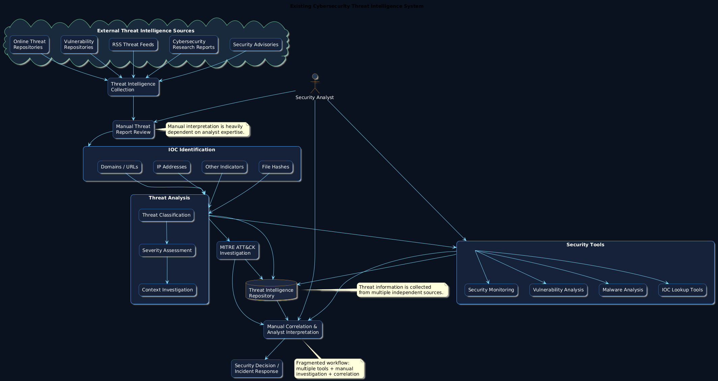

3.2 Limitations
The existing approach has several limitations when threat intelligence collection and analysis are performed through separate tools and predominantly manual workflows. The first major limitation is the high level of manual effort required to examine threat reports and identify useful security indicators. Analysts may need to manually search lengthy reports for IP addresses, domains, URLs, hashes, vulnerabilities, malware names, and other relevant information. This process can become inefficient when the volume of threat reports increases. A second limitation is the fragmentation of cybersecurity tools and information sources. When threat collection, IOC investigation, severity assessment, and attack-technique mapping are performed using separate systems, analysts must switch between multiple interfaces and correlate information manually.
Another limitation is the difficulty of maintaining consistent threat classification and severity assessment. Different analysts may interpret the same threat differently depending on their experience and available contextual information. Existing approaches may also provide limited automated contextual analysis of unstructured threat reports. Furthermore, conventional systems may not provide an integrated conversational interface through which analysts can directly query collected intelligence. The absence of such functionality can make threat investigation less interactive and efficient.
A further limitation is dependence on external sources and Internet connectivity for continuously updated intelligence. If external feeds or services are unavailable, access to current threat information may be interrupted. The proposed system specifically addresses this issue by providing seeded threat articles and a local rule-based analysis fallback so that the core application can remain functional without external API calls. Existing systems may also lack a unified environment combining RSS ingestion, IOC extraction, severity analysis, MITRE ATT&CK mapping, AI-assisted analysis, chatbot functionality, and administrative management. These limitations create the need for an integrated and extensible Cybersecurity Threat Intelligence Agent capable of reducing manual analysis and presenting structured, actionable intelligence through a single platform.

CHAPTER 4: PROPOSED SYSTEM

4.1 Proposed System
The proposed system is a Cybersecurity Threat Intelligence Agent, designed as an integrated AI-assisted platform for collecting, processing, analyzing, and presenting cybersecurity threat intelligence. The primary objective of the proposed system is to overcome the fragmented nature of conventional threat-intelligence workflows by combining threat-feed collection, Indicator of Compromise (IOC) extraction, threat classification, severity assessment, MITRE ATT&CK mapping, AI-assisted analysis, and threat-intelligence visualization within a single application. The system is implemented using a full-stack architecture consisting of React and Vite for the frontend, Python FastAPI for the backend, and SQLite3 for database management. The platform is designed with separate User and Administrator functionalities, allowing different categories of users to access appropriate cybersecurity capabilities. Users can register and authenticate themselves before accessing threat-search functionality, threat and severity detection, an AI chatbot, and file-upload facilities. Administrators have additional privileges for managing users, configuring AI services, managing RSS feeds, initiating threat-intelligence ingestion, examining historical activity, and managing system-level configurations.
The proposed system begins by collecting cybersecurity information from configured RSS threat-intelligence sources. Newly collected articles are processed through an automated IOC and threat-analysis pipeline. The IOC engine identifies relevant indicators from textual threat reports, while the threat-classification component categorizes the observed threat. A severity-calculation mechanism determines the potential importance of the identified threat, and the MITRE mapping component associates relevant threat behavior with corresponding ATT&CK techniques. The system further incorporates a Gemini-based AI service to provide enhanced analysis of collected threat information. The AI component can interpret processed intelligence and generate structured threat analysis according to the configured analysis prompt. The platform also contains a deterministic rule-based fallback mechanism, enabling the application to remain functional when external AI services or Internet connectivity are unavailable. Additionally, the application can be initialized with realistic sample threat articles, allowing its search, dashboard, and chatbot functionality to be demonstrated even without live data sources. Thus, the proposed system provides a unified environment for converting raw cybersecurity information into structured and actionable threat intelligence.
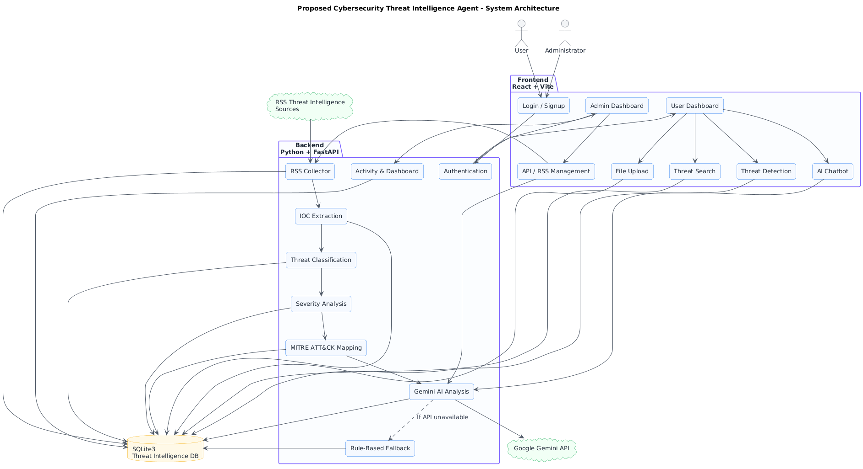

4.2 Modules Involved
The proposed Cybersecurity Threat Intelligence Agent consists of several interconnected modules that collectively implement the complete threat-intelligence processing lifecycle. The Authentication and Authorization Module manages user registration, login, administrator authentication, password security, and access control. It separates normal users from administrators so that sensitive configuration and management functionality is restricted to authorized personnel. The Threat Intelligence Collection Module is responsible for acquiring threat information from configured RSS sources. Administrators can add or remove RSS sources and initiate the ingestion process, after which newly collected articles are passed through the threat-analysis pipeline. The IOC Extraction and Threat Detection Module processes collected threat articles and identifies important indicators such as IP addresses, domains, URLs, hashes, and other relevant patterns. It also performs threat classification and severity calculation. The uploaded project specification identifies these functions as part of the IOC engine, which reproduces the corresponding notebook processing behavior.
The MITRE ATT&CK Mapping Module associates identified threat behavior with appropriate MITRE techniques, helping analysts understand the adversarial behavior represented in a threat report. The Gemini AI Analysis Module provides AI-assisted interpretation of threat information and generates structured analysis using the configured Gemini model and threat-analysis prompt. The system also maintains a rule-based fallback analyzer so that threat analysis remains available without an external AI connection. The AI Chatbot Module allows users to interact conversationally with the available threat intelligence and obtain analytical responses. The File Upload Module provides users with functionality for submitting threat-related files to the platform for processing. The Dashboard and Analytics Module aggregates threat information and presents useful statistics and analytical information through the user interface. The Administrator Module provides API integration settings, user management, RSS-feed configuration, history analysis, threat-repository access, and RSS ingestion controls. Finally, the Activity and Audit Module records relevant system activities so that administrators can examine historical operations. These modules operate together rather than as independent applications, creating a centralized platform for automated threat-intelligence processing.

4.3 Workflow
The workflow of the proposed Cybersecurity Threat Intelligence Agent begins with the acquisition of cybersecurity information from configured external threat-intelligence sources. Administrators can configure RSS feeds through the API Integration section and initiate RSS ingestion from the administrative dashboard. Once the RSS collector retrieves new articles, the collected content is passed into the threat-intelligence processing pipeline. The first major analytical stage is IOC extraction, where the system examines the textual content and identifies relevant indicators using predefined extraction patterns. The extracted information may include IP addresses, domains, URLs, file hashes, and other indicators associated with potential cyber threats. After the indicators are extracted, the system performs threat classification to determine the category or nature of the observed threat. The system subsequently performs severity calculation, allowing the collected intelligence to be prioritized according to its assessed security significance. The IOC engine, classification mechanism, severity calculation, and MITRE mapping are implemented as dedicated services within the backend architecture.
Following initial threat processing, the system performs MITRE ATT&CK mapping, associating identified threat behavior with relevant adversarial techniques. This provides additional context for security analysts and allows the threat information to be interpreted according to a recognized cybersecurity framework. The processed information is then stored in the SQLite-based threat repository, making it available for subsequent search, dashboard visualization, historical analysis, and chatbot interactions. The system can additionally pass threat information to the Gemini AI Analysis Module, which performs enhanced contextual analysis and generates structured threat intelligence. According to the project specification, the Gemini service can be configured by an administrator with an API key and model name, and AI analysis can then be triggered throughout the application. If external AI access is unavailable, the system can use its deterministic fallback analyzer. Users can subsequently search the threat repository, perform threat detection, interact with the AI chatbot, and upload relevant files. Administrators can review system history and activity while managing users, threat feeds, and API configuration. Therefore, the overall workflow converts raw threat intelligence → collected articles → IOC extraction → classification → severity assessment → MITRE mapping → AI analysis → storage → visualization and analyst interaction.

4.4 Advantages
The proposed Cybersecurity Threat Intelligence Agent provides several advantages over fragmented and predominantly manual threat-intelligence workflows. The most significant advantage is automation, because the system integrates threat collection, IOC extraction, classification, severity assessment, and MITRE mapping into a connected processing pipeline. Instead of requiring analysts to manually perform every stage, the platform automatically processes newly collected threat articles through the configured analysis services. This can reduce repetitive work and allow cybersecurity professionals to concentrate on higher-level investigation and decision-making. Another major advantage is centralization. Threat intelligence collected from multiple configured RSS sources can be processed and stored within a single platform, allowing users to search and analyze information without repeatedly switching between independent applications. The platform also provides dedicated dashboards, chatbot functionality, threat detection, and file-upload capabilities, creating a unified environment for cybersecurity intelligence activities.
The integration of AI-assisted analysis provides another important advantage. Gemini can analyze processed threat information and generate structured intelligence, potentially providing additional contextual interpretation beyond simple rule-based IOC extraction. At the same time, the deterministic fallback mechanism ensures that the application remains demonstrable when an external AI API or Internet connection is unavailable. The inclusion of MITRE ATT&CK mapping also improves the contextual value of threat intelligence by connecting observed behavior with recognized adversarial techniques. The system provides role-based functionality, allowing normal users and administrators to access different capabilities according to their responsibilities. Administrators can configure feeds, manage users, configure AI integration, initiate ingestion, and inspect historical activity, while users can focus on threat search, detection, chatbot interaction, and file uploads. Another advantage is offline demonstrability, because the system is initialized with sample threat intelligence and a local analysis mechanism. The modular FastAPI architecture also makes individual components easier to maintain and extend. Overall, the proposed system offers an integrated, automated, AI-assisted, configurable, and extensible approach to cybersecurity threat intelligence processing.

CHAPTER 5 : UML DIAGRAMS

5.1 Class Diagram
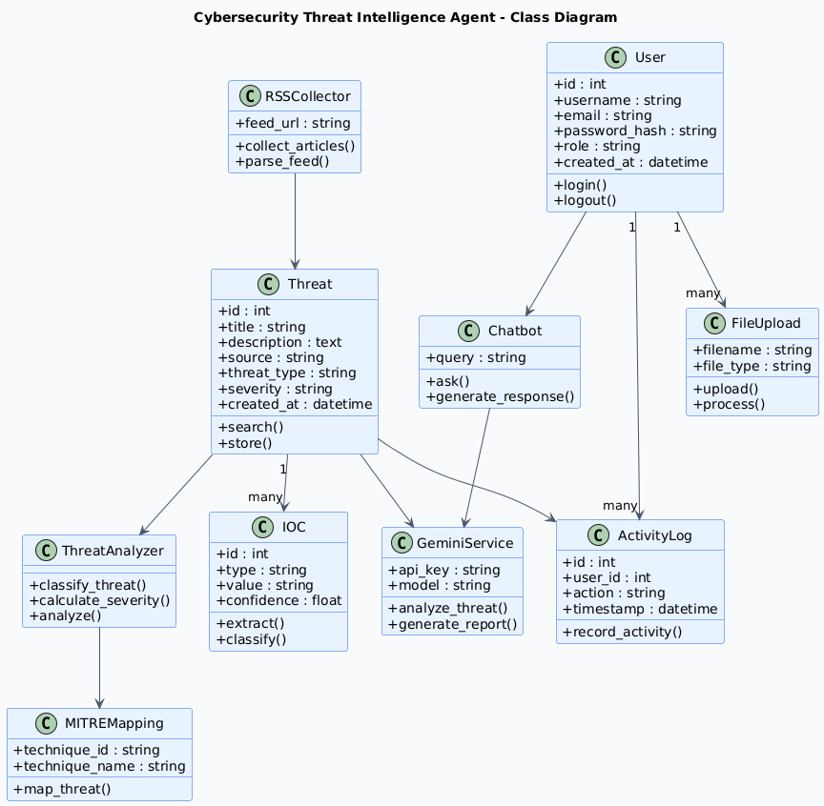

Explanation
The class diagram represents the major structural entities of the Cybersecurity Threat Intelligence Agent and the relationships among them. The system contains users with different roles, threat intelligence records, extracted IOCs, threat analyses, MITRE ATT&CK mappings, RSS feeds, uploaded files, and activity logs. The User class represents authenticated users and administrators. The Threat class stores information collected from threat-intelligence sources, while IOC represents indicators extracted from threat reports. ThreatAnalysis stores classification, severity, and AI-generated analytical information. MITREMapping represents the relationship between a threat and its corresponding ATT&CK technique. RSSFeed represents configurable intelligence sources, and UploadedFile represents files submitted by users. ActivityLog maintains historical actions for auditing. This structure corresponds to the uploaded architecture, which separates authentication, threat processing, administration, chatbot, uploads, and dashboard functionality.

5.2 Sequence Diagram
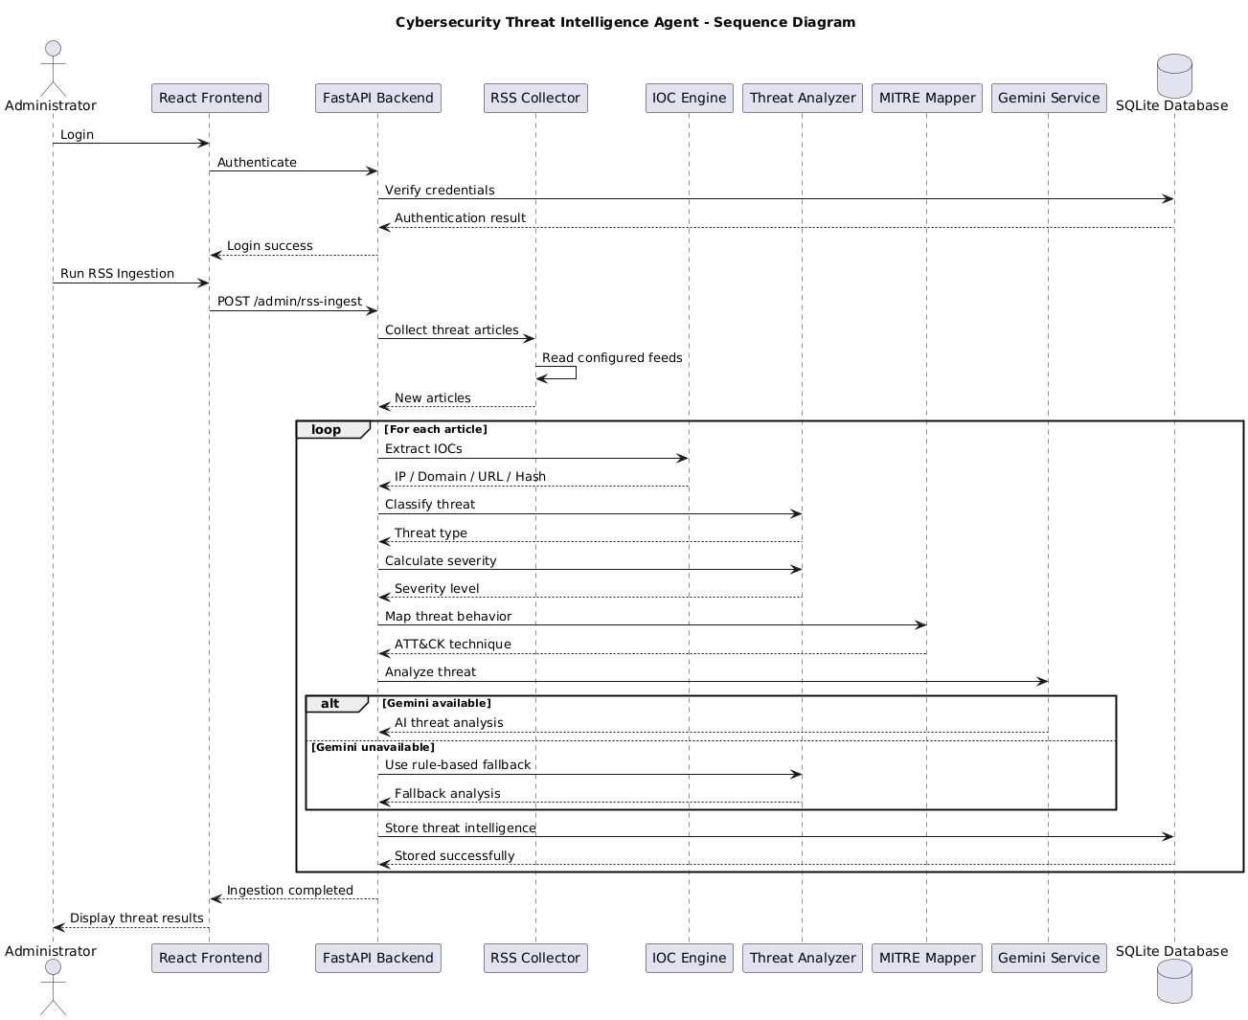

Explanation
The sequence diagram shows the interaction between the administrator, frontend, backend, RSS collector, threat-analysis engine, Gemini AI service, and database. In a typical workflow, the administrator initiates RSS ingestion from the dashboard. The backend requests articles from configured RSS sources and passes each article to the IOC engine. The extracted indicators are classified, their severity is calculated, and MITRE ATT&CK techniques are identified. The processed information is then sent to Gemini for additional AI analysis when API integration is enabled. Finally, the analyzed threat information is stored in the SQLite database and becomes available through the dashboard.

5.3 Activity Diagram
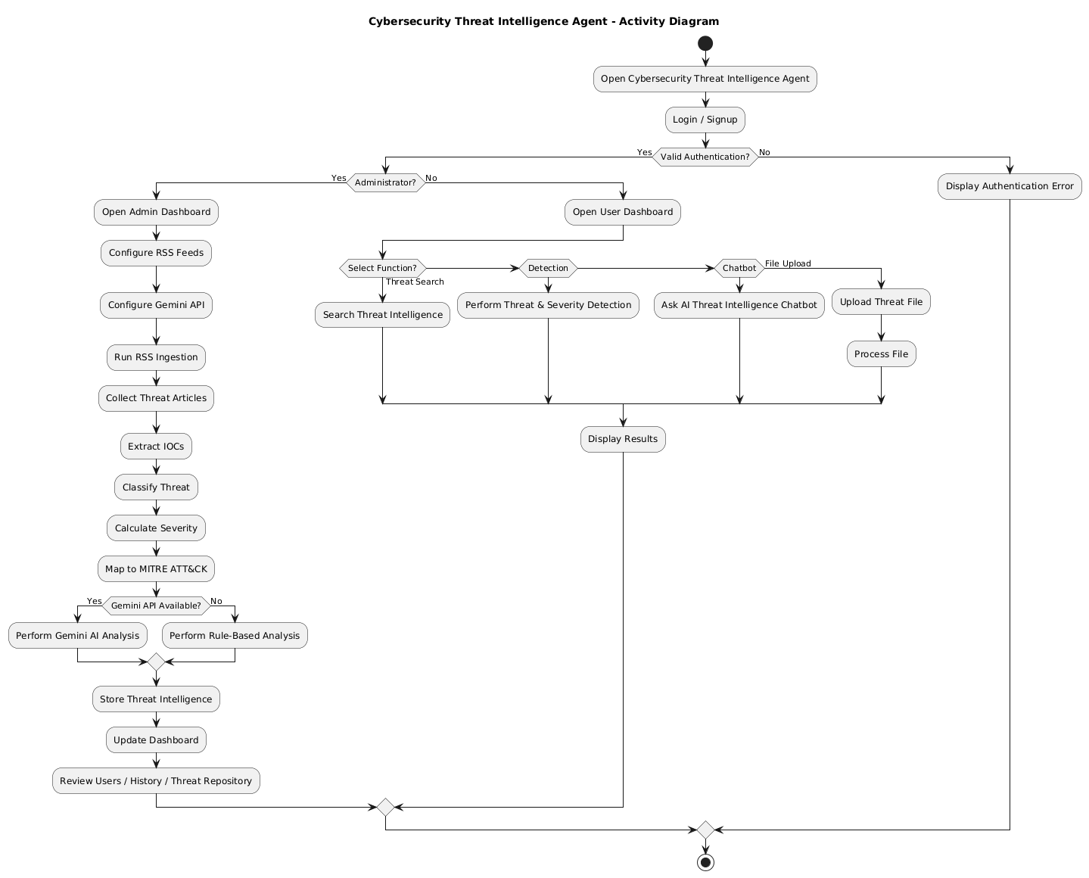

Explanation
The activity diagram represents the overall operational flow of the Cybersecurity Threat Intelligence Agent. The process starts when a user or administrator accesses the system and authenticates. Administrators can configure threat feeds and initiate ingestion, while users can search threats, perform detection, use the chatbot, or upload files. When threat information is collected, the system extracts IOCs, classifies the threat, calculates severity, maps the threat to MITRE ATT&CK, and performs AI analysis. The processed information is stored and presented through the appropriate dashboard.

5.4 Data Flow Diagram
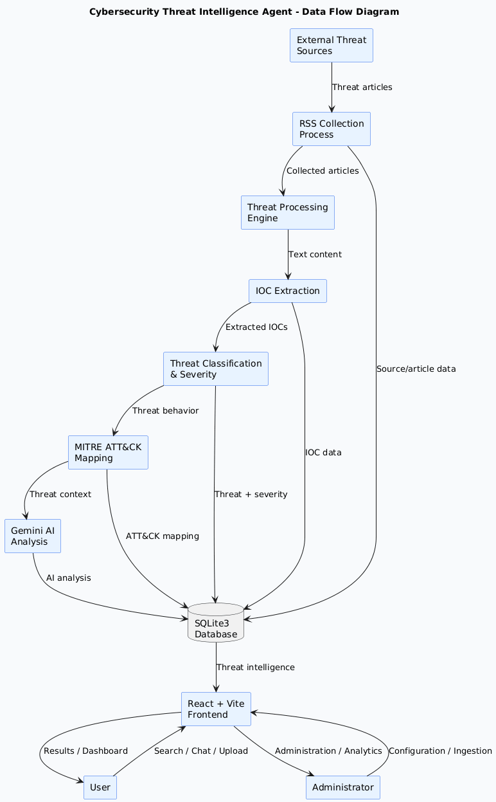

Explanation
The Data Flow Diagram illustrates how information moves through the proposed system. External threat sources provide cybersecurity information to the RSS collection component. The collected articles are sent to the threat-processing engine, where IOCs are extracted and analyzed. The resulting information is classified, assigned a severity level, and mapped to MITRE ATT&CK techniques. Gemini provides additional AI-based analysis when configured. All important results are stored in the SQLite database. Users and administrators access this information through the React/Vite frontend.

5.5 Component Diagram
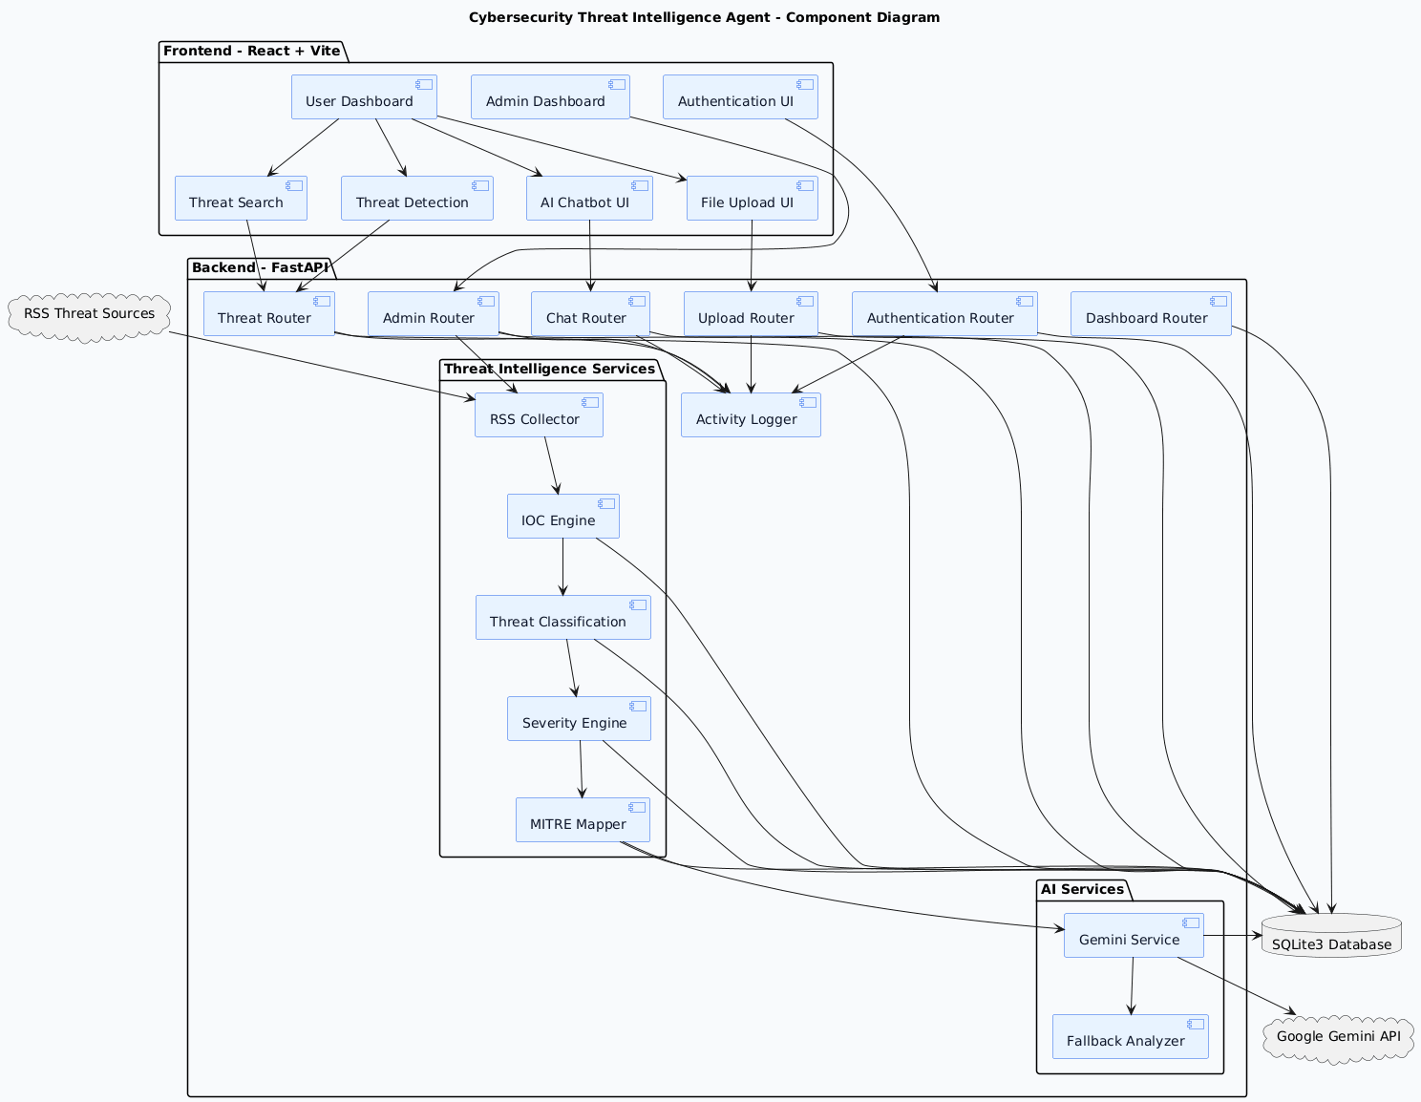

Explanation
The component diagram describes the software components of the proposed application and their dependencies. The frontend contains React/Vite pages and components for authentication, user dashboards, threat search, detection, chatbot, uploads, and administration. The backend contains FastAPI routers and services. The threat-intelligence services include RSS collection, IOC extraction, classification, severity calculation, and MITRE mapping. The Gemini service communicates with the external Gemini API. SQLite provides persistent storage, while the activity service records system operations. This structure follows the modular backend and frontend organization specified in the uploaded project.

5.6 Use Case Diagram
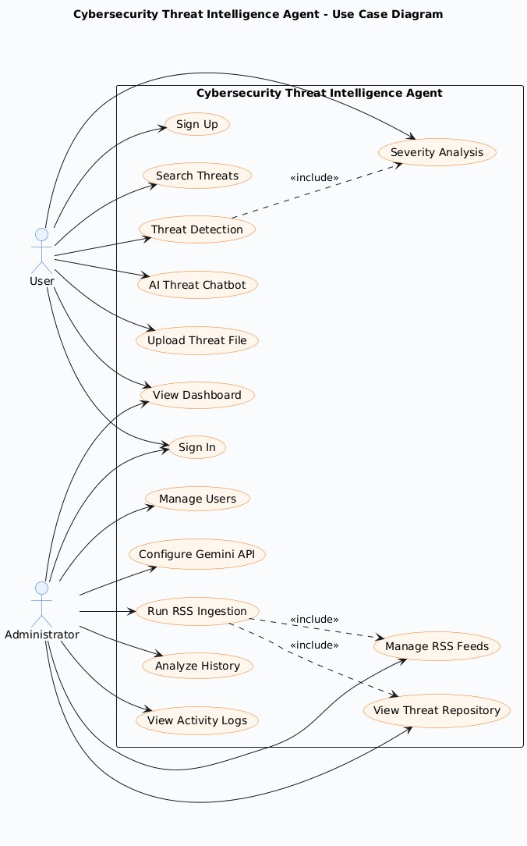

Explanation
The Use Case Diagram identifies the major interactions between the two primary actors: User and Administrator. A user can register, sign in, search threat intelligence, perform threat and severity detection, communicate with the AI chatbot, and upload files. The administrator has all necessary administrative capabilities, including user management, RSS-feed management, Gemini API configuration, threat repository management, history analysis, and RSS ingestion. The uploaded system specification explicitly separates User and Admin functionality in this manner.

5.7 Deployment Diagram
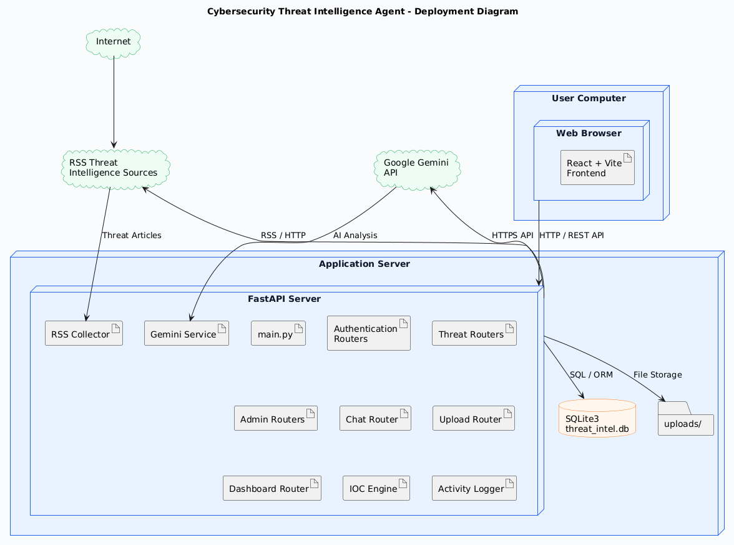

Explanation
The deployment diagram represents the physical/software environment in which the proposed system operates. The user accesses the React/Vite frontend through a web browser. The frontend communicates with the Python FastAPI backend through HTTP/API requests. The FastAPI server manages authentication, threat processing, RSS collection, AI analysis, file uploads, dashboards, and administration. SQLite3 is used as the local database. The backend can communicate with external RSS sources for live threat intelligence and with the Google Gemini API when AI analysis is enabled. The project specification states that the backend runs on port 8000 and the Vite frontend on port 5173 during development
CHAPTER 6 : LIBRARIES

6.1 Core Machine Learning & Deep Learning Frameworks

6.1.1 TensorFlow 2.10+
TensorFlow is an open-source end-to-end machine learning platform developed by Google Brain. It provides a comprehensive ecosystem of tools, libraries, and community resources that enable researchers and developers to build and deploy machine learning applications. TensorFlow's flexible architecture allows easy deployment of computation across various platforms, from desktops to clusters of servers and even mobile devices.
In the context of this project, TensorFlow serves as the foundational framework for constructing, training, and evaluating deep neural networks. Its Keras high-level API simplifies model building while the lower-level operations support fine-grained customization.

Property | Details
Library Name | TensorFlow
Version | 2.10.0 or above
Developer | Google Brain Team
License | Apache License 2.0
Installation | pip install tensorflow==2.10.0
Python Support | Python 3.7 – 3.10
Primary Use | Deep learning model training, Neural network construction
Table 6.1 – TensorFlow Library Properties

6.1.2 PyTorch 1.13+
PyTorch is an open-source machine learning library developed by Meta AI (formerly Facebook AI Research). It is widely adopted in academia and industry for its dynamic computational graph feature (eager execution), which makes debugging and model iteration significantly easier compared to static graph frameworks. PyTorch's torch.nn module provides building blocks for creating complex neural architectures.
PyTorch is the primary framework used for implementing Transformer-based architectures, attention mechanisms, and custom neural network layers in this project. It supports both CPU and GPU-accelerated training through CUDA.

Property | Details
Library Name | PyTorch
Version | 1.13.0 or above
Developer | Meta AI Research (Facebook)
License | BSD-3-Clause
Installation | pip install torch torchvision torchaudio
Python Support | Python 3.7 – 3.10
Primary Use | Dynamic neural networks, Transformer models, GPU acceleration
Table 6.2 – PyTorch Library Properties

6.1.3 Hugging Face Transformers 4.30+
The Transformers library by Hugging Face provides thousands of pretrained models for Natural Language Processing (NLP), Computer Vision, and multimodal tasks. It supports frameworks including PyTorch and TensorFlow, and provides unified APIs for loading, fine-tuning, and deploying state-of-the-art transformer models such as BERT, GPT, T5, RoBERTa, ViT, and CLIP.
In this project, the Transformers library is essential for integrating pretrained LLMs and vision-language models, enabling rapid fine-tuning on domain-specific datasets and deploying inference pipelines efficiently.

Property | Details
Library Name | Hugging Face Transformers
Version | 4.30.0 or above
Developer | Hugging Face Inc.
License | Apache License 2.0
Installation | pip install transformers
Python Support | Python 3.7 – 3.10
Primary Use | Pretrained LLMs, fine-tuning, NLP pipelines
Table 6.3 – Hugging Face Transformers Library Properties

6.2 Data Processing and Scientific Computing Libraries

6.2.1 NumPy 1.23+
NumPy (Numerical Python) is the fundamental package for scientific computing in Python. It provides support for large, multi-dimensional arrays and matrices, along with a collection of mathematical functions to operate on these arrays efficiently. NumPy forms the backbone of nearly all scientific Python libraries including SciPy, Pandas, and deep learning frameworks.

Property | Details
Library Name | NumPy
Version | 1.23.0 or above
Installation | pip install numpy
Primary Use | Array operations, matrix computation, numerical processing
Table 6.4 – NumPy Library Properties

6.2.2 Pandas 1.5+
Pandas is a fast, powerful, flexible, and easy-to-use open-source data analysis and manipulation library for Python. It provides two primary data structures: Series (1-dimensional) and DataFrame (2-dimensional), which are used for managing structured data. Pandas integrates seamlessly with NumPy and Matplotlib, making it the standard tool for tabular data processing.
In this project, Pandas is used for dataset loading, preprocessing, splitting, aggregation, and feature engineering on structured input data.

6.2.3 Scikit-learn 1.1+
Scikit-learn is the most widely used Python library for traditional machine learning tasks. It provides simple and efficient tools for data mining and analysis, including classification, regression, clustering, dimensionality reduction, model selection, and preprocessing. Scikit-learn is built on top of NumPy, SciPy, and Matplotlib.
Within this project, Scikit-learn handles evaluation metrics, cross-validation, label encoding, feature scaling, and baseline model comparisons.

Library | Primary Role in Project
Pandas 1.5+ | Data loading, preprocessing, DataFrame operations
Scikit-learn 1.1+ | Metrics, cross-validation, label encoding
SciPy 1.9+ | Statistical analysis, optimization routines
Matplotlib 3.6+ | Training curves, visualization, plotting
Seaborn 0.12+ | Statistical data visualization, heatmaps
Table 6.5 – Data Processing Libraries Summary

6.3 Natural Language Processing & LLM Support Libraries

6.3.1 LangChain 0.1+
LangChain is a framework for building applications powered by Large Language Models. It provides abstractions for chaining LLM calls, managing memory/context, integrating vector databases, and building multi-step reasoning agents. LangChain supports various LLM backends including OpenAI, Anthropic, Hugging Face, and local models.
In this project, LangChain is used for building Retrieval-Augmented Generation (RAG) pipelines, constructing agent workflows, and managing conversation history for context-aware response generation.

6.3.2 NLTK & spaCy
NLTK (Natural Language Toolkit) is a leading platform for building Python programs that work with human language data. It provides interfaces for over 50 corpora and lexical resources and a suite of text processing libraries including tokenization, parsing, stemming, and tagging. spaCy is an industrial-strength NLP library offering fast and accurate linguistic annotations with pre-trained statistical models for multiple languages.

Library | Key Functions
LangChain 0.1+ | LLM chaining, RAG pipelines, agent orchestration
NLTK 3.8+ | Tokenization, stemming, lemmatization, corpus access
spaCy 3.5+ | Named Entity Recognition, POS tagging, dependency parsing
Sentence-Transformers | Semantic embeddings, similarity computation
FAISS / ChromaDB | Vector store, semantic search index
Table 6.6 – NLP & LLM Support Libraries

CHAPTER 7 MODULES EXPLANATION

This chapter describes the modular architecture of the proposed system. The system is organized into well-defined functional modules, each responsible for a specific set of tasks. This modular design promotes code reusability, maintainability, scalability, and independent testing. The modules interact with each other through defined interfaces and data pipelines built on the Python 3.10.0 runtime.

7.1 System Module Architecture Overview
The overall system is structured into six primary modules: Data Acquisition and Preprocessing, Feature Engineering, Model Architecture, Training and Optimization, Inference and Post-processing, and Evaluation and Visualization. Each module encapsulates a cohesive set of responsibilities and communicates via standardized data formats.

Module ID | Module Name | Libraries Involved
MOD-01 | Data Acquisition & Preprocessing | Pandas, NumPy, OpenCV
MOD-02 | Feature Engineering | Scikit-learn, TF-IDF, Embeddings
MOD-03 | Model Architecture | PyTorch, TensorFlow, Transformers
MOD-04 | Training & Optimization | PyTorch Lightning, Adam, Scheduler
MOD-05 | Inference & Post-processing | LangChain, FAISS, Softmax
MOD-06 | Evaluation & Visualization | Scikit-learn, Matplotlib, Seaborn
Table 7.1 – System Module Overview

7.2 Module 1: Data Acquisition and Preprocessing

7.2.1 Purpose and Responsibilities
The Data Acquisition and Preprocessing module is the entry point of the system pipeline. It is responsible for collecting raw data from multiple sources (CSV files, APIs, databases, web scrapers), validating data integrity, and transforming it into a clean, structured format suitable for downstream processing. This module handles missing value imputation, outlier removal, normalization, and data type conversions.

7.2.2 Sub-components
- Data Loader: Reads data from local file systems, URLs, and database connections using Pandas read_csv, read_json, and SQLAlchemy connectors.
- Data Cleaner: Handles null values using forward fill, backward fill, or mean/median substitution strategies depending on the column type.
- Data Normalizer: Applies MinMaxScaler or StandardScaler from Scikit-learn to normalize numerical features to a consistent range.
- Data Splitter: Divides the dataset into training, validation, and test sets with configurable ratios (default: 70:15:15) ensuring stratified sampling.
- Data Augmenter: For image-based inputs, applies random flips, rotations, color jitter, and Gaussian noise using torchvision.transforms.

Key Python Functions Used:
pd.read_csv(), df.dropna(), df.fillna(), sklearn.preprocessing.StandardScaler(), train_test_split(), torchvision.transforms.Compose()

7.3 Module 2: Feature Engineering

The Feature Engineering module transforms cleaned raw data into meaningful numerical representations that can be ingested by machine learning models. This module implements domain-specific feature extraction strategies appropriate for the type of input data (text, images, tabular, or multimodal).

7.3.1 Text Feature Extraction
- TF-IDF Vectorization: Converts text documents into numerical feature vectors using term frequency–inverse document frequency weighting.
- Word Embeddings: Generates dense vector representations using pre-trained GloVe, FastText, or Word2Vec models loaded through the gensim library.
- Sentence Embeddings: Uses Sentence-Transformers (e.g., all-MiniLM-L6-v2) to generate fixed-length semantic sentence representations.

7.3.2 Image Feature Extraction
- Convolutional Feature Maps: Extracts hierarchical spatial features using pretrained CNN backbones (ResNet, EfficientNet) with PyTorch's torchvision.models.
- Patch Embeddings: For Vision Transformer (ViT) models, images are divided into fixed-size patches and linearly projected into embedding space.

Feature Type | Technique | Output Dimension
Text (Short) | TF-IDF + SVD | 512-d vector
Text (Long) | BERT CLS Token | 768-d vector
Image | ResNet-50 Pooling | 2048-d vector
Image (Transformer) | ViT Patch Embed | 768-d vector
Tabular | StandardScaler | N features
Multimodal | Concatenation / Cross-Attn | 1024–2048-d
Table 7.2 – Feature Engineering Strategies and Output Dimensions

7.4 Module 3: Model Architecture

The Model Architecture module encapsulates the neural network design and configuration. It defines the layer-by-layer structure, attention mechanisms, fusion strategies, and output heads relevant to the specific project objective. The module is implemented in PyTorch using nn.Module class hierarchy, allowing modular composition of sub-networks.

7.4.1 Encoder Block
The encoder block processes input embeddings through stacked multi-head self-attention layers and position-wise feed-forward networks. Each layer incorporates residual connections and layer normalization to stabilize gradient flow during training. The encoder captures contextual relationships across the full input sequence.

7.4.2 Attention Mechanism
The scaled dot-product attention mechanism computes attention scores by taking the dot product of query and key matrices, scaling by the square root of the key dimension, applying softmax normalization, and performing weighted aggregation of value vectors. Multi-head attention extends this by running multiple parallel attention operations and concatenating their outputs.

7.4.3 Classification / Regression Head
- Classification tasks: Fully connected layers with ReLU activations followed by a Softmax output layer. Cross-Entropy loss is used for optimization.
- Regression tasks: Fully connected layers ending with a linear output unit. Mean Squared Error (MSE) or Huber loss is applied.
- Generation tasks: Decoder block with causal masking, cross-attention to encoder outputs, and vocabulary projection with log-softmax.

7.5 Module 4: Training and Optimization

The Training and Optimization module manages the complete training lifecycle of the model, from forward pass computation to loss calculation, gradient computation, parameter updates, and learning rate scheduling. It supports both single-GPU and multi-GPU distributed training configurations.

7.5.1 Training Configuration
Parameter | Default Value / Strategy
Optimizer | AdamW (weight_decay=1e-2)
Learning Rate | 2e-5 (with warmup scheduling)
Batch Size | 32 (train) / 16 (validation)
Epochs | 30 (with early stopping patience=5)
LR Scheduler | CosineAnnealingLR / Linear Warmup
Gradient Clipping | max_norm=1.0
Mixed Precision | torch.cuda.amp.autocast() (FP16)
Table 7.3 – Training Hyperparameters and Configuration

7.5.2 Callbacks and Monitoring
- ModelCheckpoint: Saves model weights at every epoch where validation loss improves.
- EarlyStopping: Halts training if validation metric does not improve for a configurable number of epochs, preventing overfitting.
- TensorBoard Logger: Logs training and validation loss, accuracy, learning rate, and gradient norms at each step for real-time monitoring.

7.6 Module 5: Inference and Post-processing

The Inference module handles the deployment of trained models for making predictions on new, unseen data. It loads saved model checkpoints, configures the model in evaluation mode (model.eval()), disables gradient computation (torch.no_grad()), and processes inputs through the forward pass to generate outputs.

7.6.1 Inference Pipeline
- Input Preprocessing: Raw input is passed through the same preprocessing and feature extraction pipeline used during training to ensure consistency.
- Model Forward Pass: Preprocessed tensor inputs are forwarded through the loaded model to produce raw logits or probability distributions.
- Post-processing: Output logits are decoded into human-readable predictions using argmax (classification), threshold (binary), or beam search (generation).
- Confidence Scoring: Softmax probabilities are used as confidence scores to flag low-confidence predictions for human review.

RAG-Specific Inference:
For Retrieval-Augmented Generation modules, the inference pipeline includes a vector similarity search step using FAISS or ChromaDB to retrieve top-k relevant context documents before passing the augmented prompt to the LLM.

CHAPTER 8 SOFTWARE AND HARDWARE SPECIFICATIONS

This chapter presents the complete software and hardware environment required to develop, train, and deploy the proposed AI system. Proper configuration of both software dependencies and hardware resources is critical for achieving optimal model performance and training efficiency. All specifications listed here correspond to the environment used during project development and experimentation.

8.1 Software Specifications

8.1.1 Operating System
The project was developed and tested on multiple operating systems to ensure cross-platform compatibility. The primary development environment used Ubuntu 22.04 LTS for GPU-accelerated training, while Windows 11 Pro was used for frontend and documentation tasks.

Parameter | Specification
Primary OS (Training) | Ubuntu 22.04 LTS (64-bit)
Secondary OS | Windows 11 Pro (64-bit)
macOS Support | macOS Ventura 13.x (Apple Silicon)
Container Support | Docker 24.x / NVIDIA Docker 2.x
Table 8.1 – Operating System Specifications

8.1.2 Python 3.10.0 – Core Language Environment
Python 3.10.0 is the core programming language used throughout this project. Released in October 2021, Python 3.10 introduces significant improvements including structural pattern matching (match/case statements), precise error messages with better tracebacks, improved type hints with union operators (X | Y syntax), and performance enhancements in the CPython interpreter.

Attribute | Details
Language | Python
Version | 3.10.0 (October 4, 2021)
Download | https://www.python.org/downloads/release/python-3100/
Key Feature | Structural pattern matching (match/case)
Key Feature | Parenthesized context managers
Key Feature | Better error messages with precise location
Key Feature | Union type operator: X | Y (PEP 604)
Interpreter | CPython 3.10.0 (reference implementation)
Package Manager | pip 22.x / conda 4.x
Virtual Env | venv (built-in) / virtualenv 20.x
Table 8.2 – Python 3.10.0 Specification

Python 3.10.0 Installation Command (Ubuntu/Linux):
sudo apt update && sudo apt install -y software-properties-common
sudo add-apt-repository ppa:deadsnakes/ppa
sudo apt install python3.10 python3.10-venv python3.10-dev

8.1.3 Integrated Development Environment (IDE)
The following development tools and IDEs were used across different phases of the project:

Tool / IDE | Purpose and Version
Visual Studio Code 1.80+ | Primary code editor with Python, Pylance, Jupyter extensions
Jupyter Notebook / JupyterLab | Interactive experimentation and prototyping
Google Colab Pro+ | Cloud GPU training and dataset exploration
PyCharm CE 2023+ | Full-featured IDE for module development
Git 2.40+ / GitHub | Version control and collaborative code management
Docker Desktop 4.x | Containerized deployment and reproducible environments
Table 8.3 – Development Tools and IDEs

8.1.4 Complete Python Dependencies (requirements.txt)
The following table lists all major Python packages and their minimum required versions for the project. A complete requirements.txt file is maintained in the project repository root directory.

Package | Min. Version | Category
torch | 1.13.0 | Deep Learning
tensorflow | 2.10.0 | Deep Learning
transformers | 4.30.0 | NLP / LLM
langchain | 0.1.0 | LLM Orchestration
numpy | 1.23.0 | Scientific Computing
pandas | 1.5.0 | Data Processing
scikit-learn | 1.1.0 | ML Utilities
matplotlib | 3.6.0 | Visualization
seaborn | 0.12.0 | Statistical Visualization
opencv-python | 4.7.0 | Computer Vision
Pillow | 9.3.0 | Image Processing
faiss-cpu | 1.7.3 | Vector Search
sentence-transformers | 2.2.0 | Semantic Embeddings
gradio | 3.40.0 | Web UI / Demo
fastapi | 0.100.0 | REST API Backend
uvicorn | 0.22.0 | ASGI Server
Table 8.4 – Python Package Dependencies

8.2 Hardware Specifications

The hardware configuration plays a critical role in determining the speed of model training and inference. The following subsections detail the minimum, recommended, and high-performance hardware configurations used in different stages of this project.

8.2.1 Development Workstation (Minimum Recommended)

Component | Minimum Specification
Processor (CPU) | Intel Core i7-10th Gen / AMD Ryzen 7 5800X or higher
RAM (System Memory) | 16 GB DDR4 (32 GB recommended)
GPU (Graphics Card) | NVIDIA GeForce RTX 2060 (6 GB VRAM minimum)
Storage (Primary) | 512 GB NVMe SSD
Storage (Secondary) | 1 TB HDD for dataset storage
Operating System | Ubuntu 22.04 LTS / Windows 11 Pro
Internet Connection | 100 Mbps broadband (for dataset downloads / APIs)
Table 8.5 – Minimum Development Hardware Specifications

8.2.2 High-Performance Training Configuration

Component | High-Performance Specification
Processor (CPU) | Intel Core i9-13900K / AMD Threadripper 3960X (24 cores)
RAM (System Memory) | 64 GB DDR5 ECC (128 GB for large language models)
GPU (Primary) | NVIDIA RTX 4090 (24 GB GDDR6X VRAM)
GPU (Multi-GPU Training) | 2x NVIDIA A100 80GB (DGX Configuration)
Storage (Primary) | 2 TB NVMe PCIe Gen 4 SSD (Read: 7000 MB/s)
Storage (Dataset) | 8 TB NAS / SAN Storage Array
Network Interface | 10 Gbps Ethernet (Multi-node distributed training)
Power Supply | 1200W 80+ Platinum PSU
Table 8.6 – High-Performance Training Hardware Specifications

8.2.3 GPU Memory Requirements by Model Type

Model Type | Example Architecture | VRAM Required
Small Transformer | BERT-Base (110M params) | 4 GB
Medium Transformer | RoBERTa-Large (355M) | 8 GB
Large Transformer | GPT-2 Large (774M) | 12 GB
Vision Transformer | ViT-L/16 (307M) | 10 GB
Multimodal Model | CLIP ViT-L (400M) | 16 GB
LLM (Fine-tune) | LLaMA-7B with LoRA | 24 GB
LLM (Full Train) | LLaMA-13B | 80 GB (A100)
Table 8.7 – GPU Memory Requirements by Model Architecture

8.3 Cloud Computing and External APIs

For large-scale training and experiments beyond the capacity of local hardware, cloud computing resources and external API services are integrated into the project workflow. The following platforms are utilized:

Platform / Service | Key Features | Use Case
Google Colab Pro+ | T4/A100 GPU, 51GB RAM, 100 compute units | Rapid prototyping
AWS SageMaker | Auto-scaling, managed ML platform, spot instances | Production training
Hugging Face Hub | Model registry, dataset hosting, Spaces deployment | Model sharing
Weights & Biases | Experiment tracking, hyperparameter sweeps, artifacts | MLOps monitoring
OpenAI API | GPT-4 inference, embedding generation | LLM baseline comparison
Table 8.8 – Cloud Platforms and External API Services

8.4 CUDA and GPU Computing Stack

GPU-accelerated computation is a fundamental requirement for training deep learning models efficiently. The CUDA (Compute Unified Device Architecture) platform by NVIDIA enables parallelized tensor operations across thousands of GPU cores, drastically reducing training time compared to CPU-only execution.

Component | Version / Details
CUDA Toolkit | CUDA 11.7 / 11.8 (recommended for PyTorch 1.13+)
cuDNN | cuDNN 8.5+ (GPU-accelerated deep learning primitives)
NVIDIA Driver | 520.x or above
PyTorch CUDA Build | torch==1.13.0+cu117 or cu118
TensorFlow GPU Build | tensorflow-gpu==2.10.0
Mixed Precision | Automatic Mixed Precision (AMP) via torch.cuda.amp
Multi-GPU Strategy | torch.nn.DataParallel / DistributedDataParallel (DDP)
Table 8.9 – CUDA and GPU Computing Stack

Verify GPU Setup (Python 3.10.0):
import torch
print('CUDA Available:', torch.cuda.is_available())
print('GPU Device:', torch.cuda.get_device_name(0))
print('CUDA Version:', torch.version.cuda)

8.5 Complete System Configuration Summary

The following table summarizes the complete software and hardware environment recommended for replicating the experimental results presented in this project. Deviations from the recommended configuration may result in longer training times or minor performance differences.

Category | Recommended Configuration
Programming Language | Python 3.10.0
Operating System | Ubuntu 22.04 LTS (64-bit)
Deep Learning Framework | PyTorch 1.13+ / TensorFlow 2.10+
LLM Framework | Hugging Face Transformers 4.30+
GPU | NVIDIA RTX 3090/4090 (24 GB VRAM)
CPU | AMD Ryzen 9 / Intel Core i9 (12+ cores)
RAM | 64 GB DDR4/DDR5
Primary Storage | 1 TB NVMe SSD
CUDA Version | CUDA 11.7 or 11.8
IDE | VS Code 1.80+ with Python Extension
Version Control | Git 2.40+ / GitHub
Containerization | Docker 24.x + NVIDIA Container Toolkit
Table 8.10 – Complete System Configuration Summary

CHAPTER 9 : Source Code
import os

from fastapi import FastAPI
from fastapi.middleware.cors import CORSMiddleware

from database import Base, engine
from routers import auth_router, threats_router, admin_router, chat_router, upload_router, dashboard_router
from seed_data import seed

Base.metadata.create_all(bind=engine)
seed()

app = FastAPI(
title="Cybersecurity Threat Intelligence Agent API",
description="Backend for the RSS-driven Threat Intelligence platform "
"(IOC extraction, classification, severity scoring, MITRE "
"ATT&CK mapping, Gemini AI analysis, chatbot, and admin ops).",
version="1.0.0",
)

# NOTE: allow_origins=["*"] combined with allow_credentials=True is invalid
# per the CORS spec (browsers reject/strip credentialed requests against a
# wildcard origin) and, if it did work, would be an overly permissive policy
# for a credentialed/token-bearing API. Configure explicit origins via the
# CORS_ORIGINS env var (comma-separated) instead, defaulting to the Vite
# dev server origins.
_default_origins = "http://localhost:5173,http://127.0.0.1:5173"
CORS_ORIGINS = [o.strip() for o in os.environ.get("CORS_ORIGINS", _default_origins).split(",") if o.strip()]

app.add_middleware(
CORSMiddleware,
allow_origins=CORS_ORIGINS,
allow_credentials=True,
allow_methods=["*"],
allow_headers=["*"],
)

app.include_router(auth_router.router)
app.include_router(threats_router.router)
app.include_router(admin_router.router)
app.include_router(chat_router.router)
app.include_router(upload_router.router)
app.include_router(dashboard_router.router)

@app.get("/api/health")
def health_check():
return {"status": "ok", "service": "Cybersecurity Threat Intelligence Agent"}

CHAPTER 10 : RESULTS AND DISCUSSION
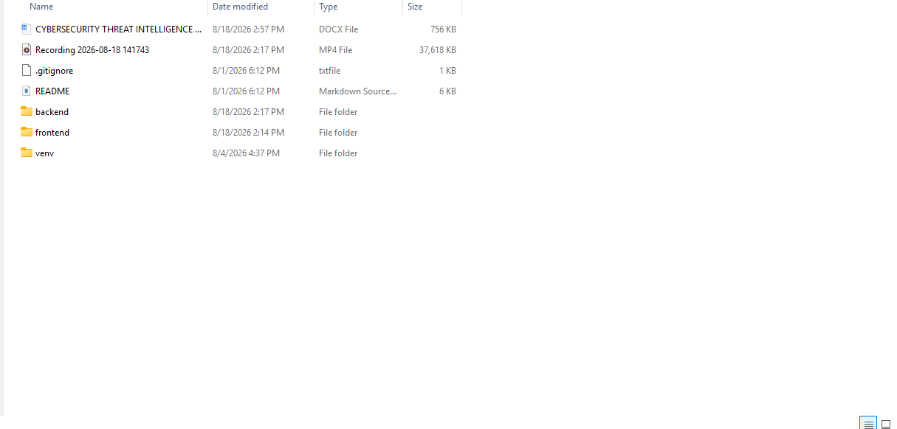
Fig 1 : Project folder
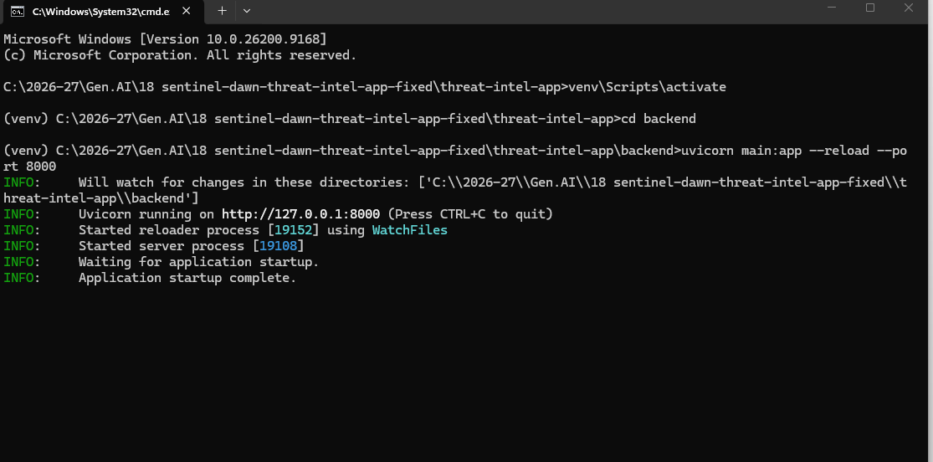
Fig 2 : Access the command prompt from the Project folder, activate the virtual environment, move to backend folder and execute the backend
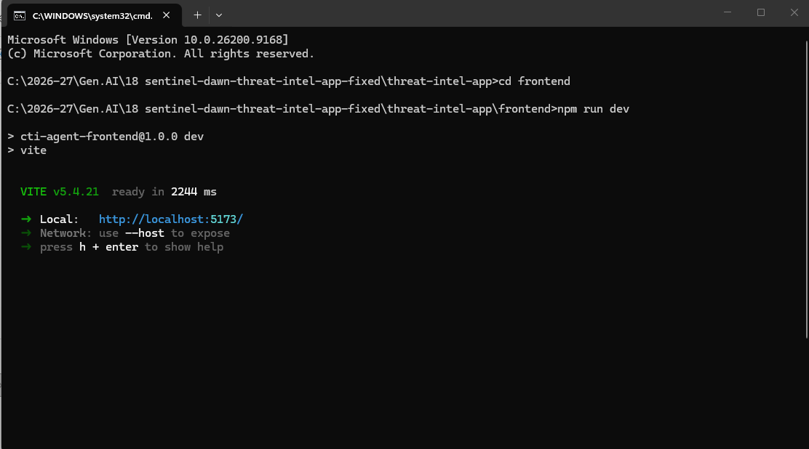
Fig 3 : Access the new command prompt , move to frontend folder and execute the frontend
Then access the web link in any browser
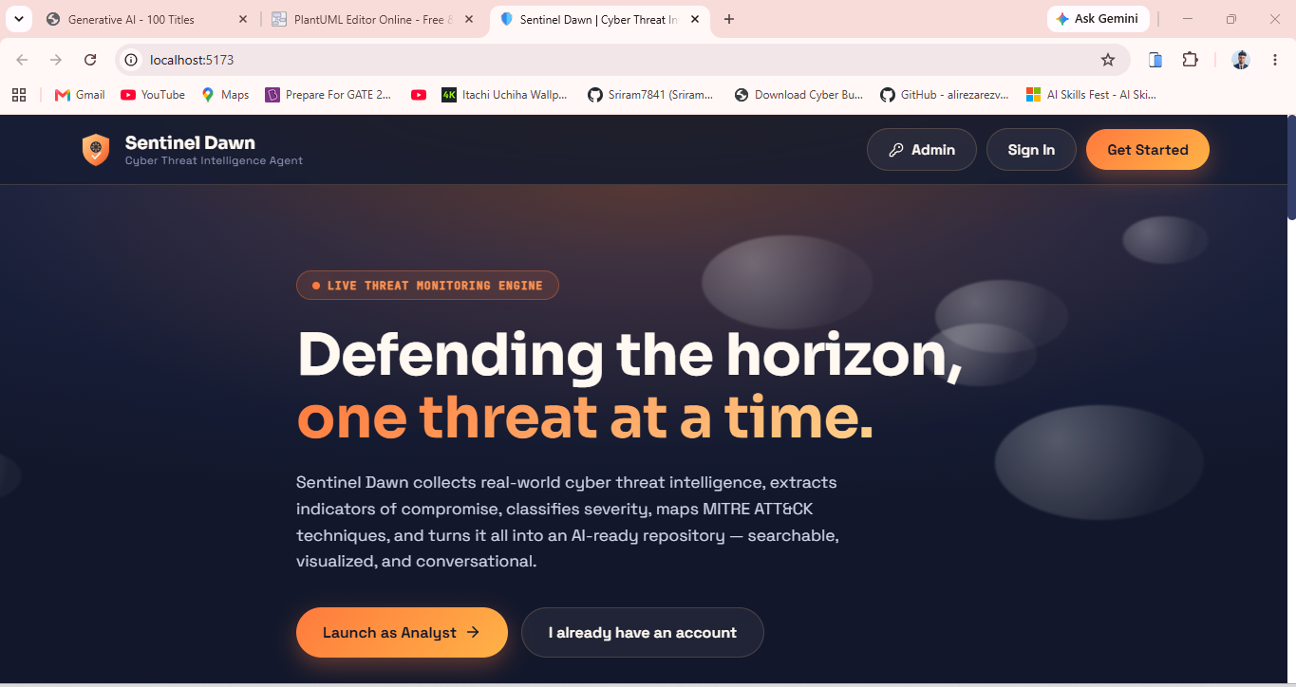
Fig 4 : The Home UI
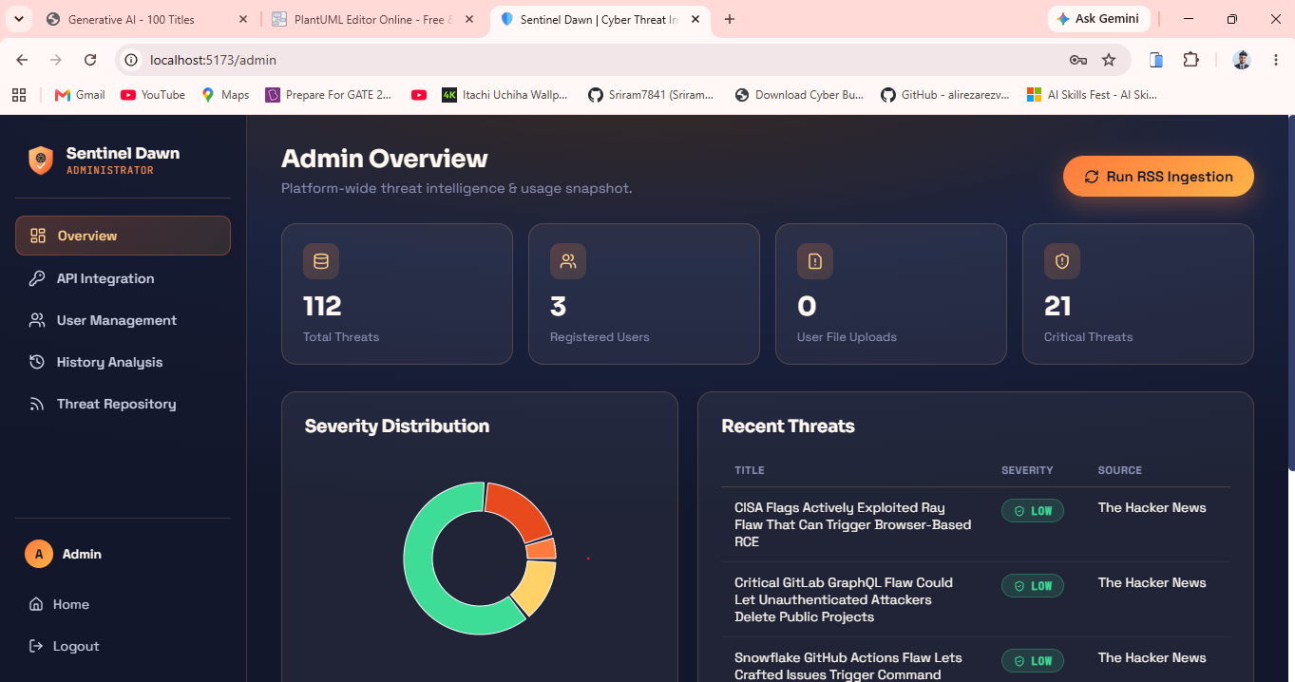
Fig 5 : Admin dashboard
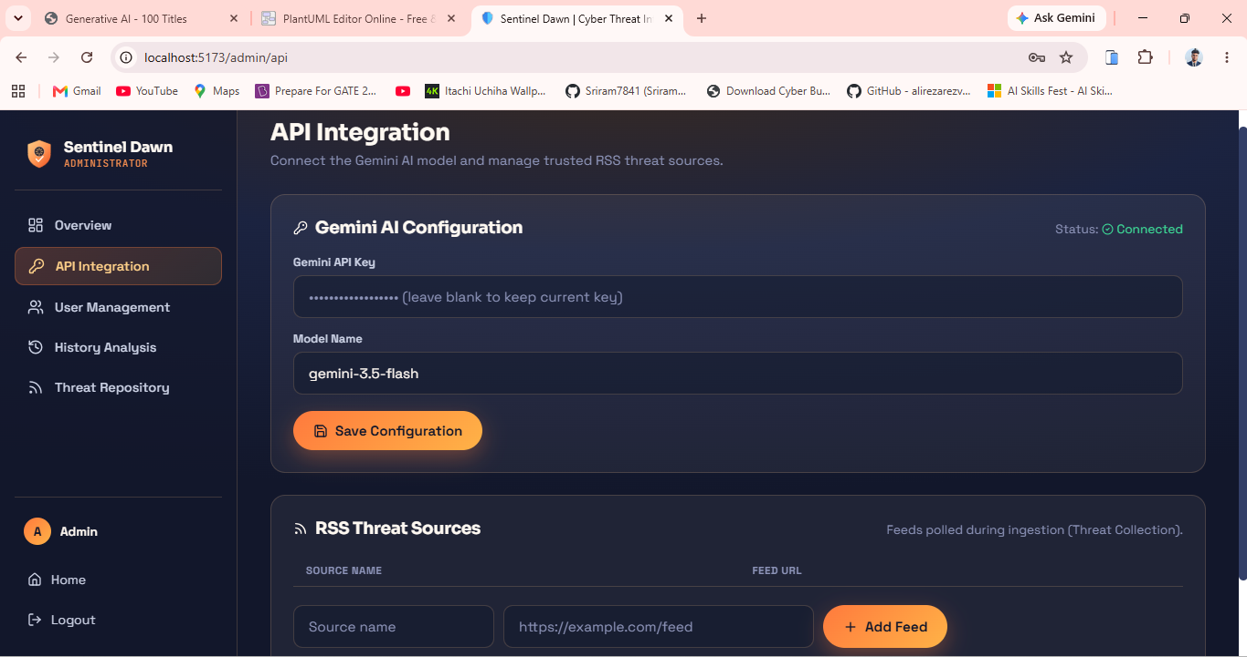
Fig 6 : Api key integration - Admin module
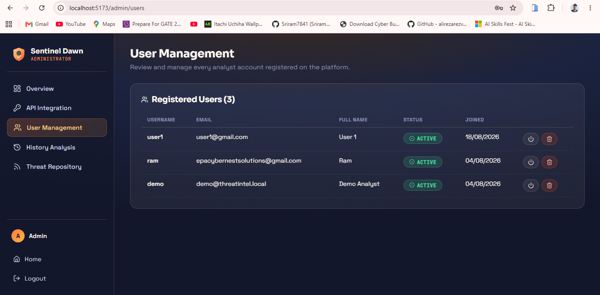
Fig 7 : User management -Admin module
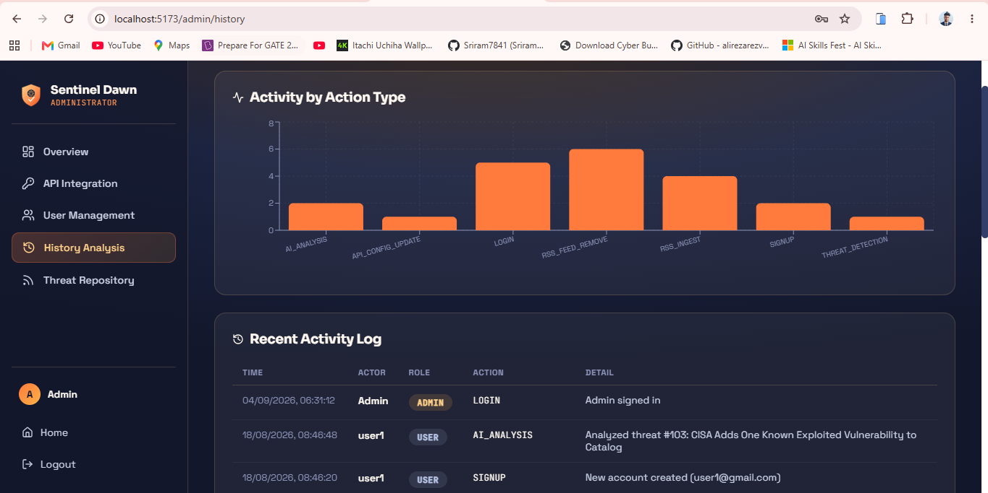
Fig 8 : History analysis - Admin module
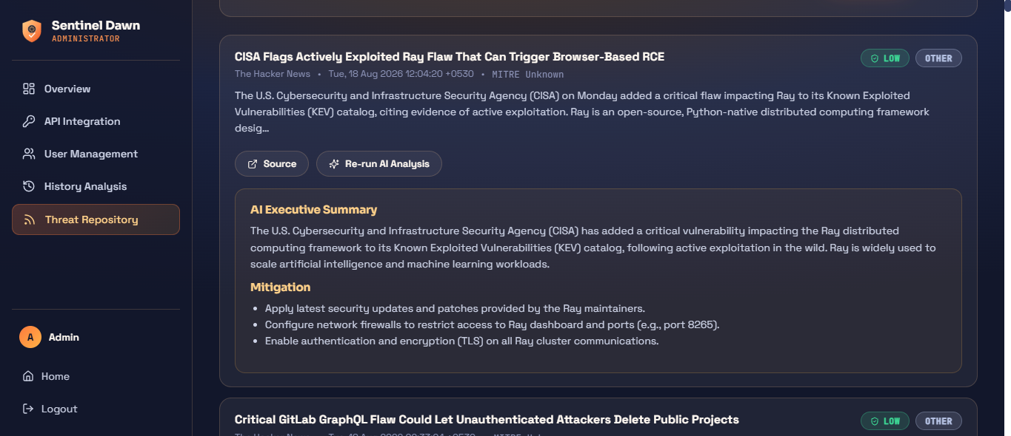
Fig 9 : Threat repository - Admin module
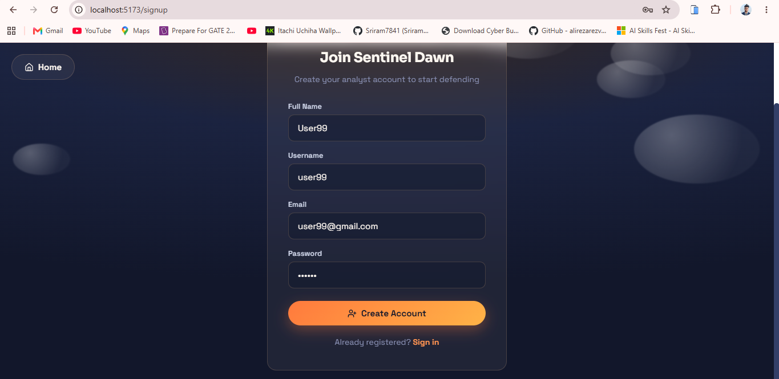
Fig 10: new user registration
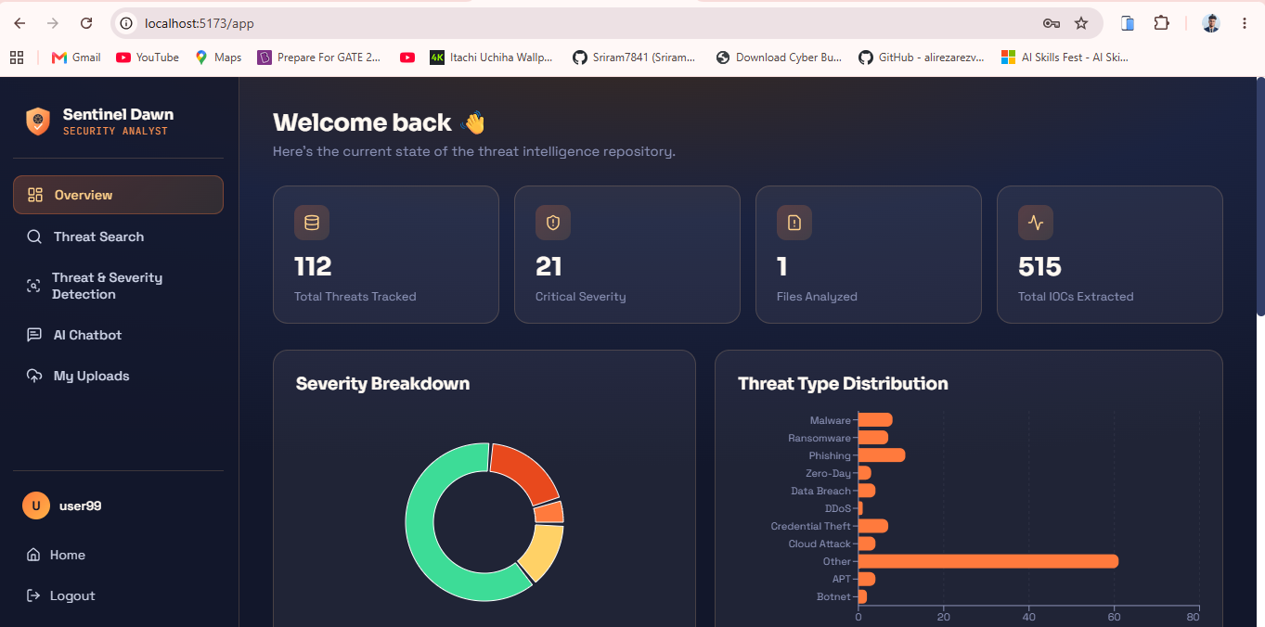
Fig 11: user dashboard
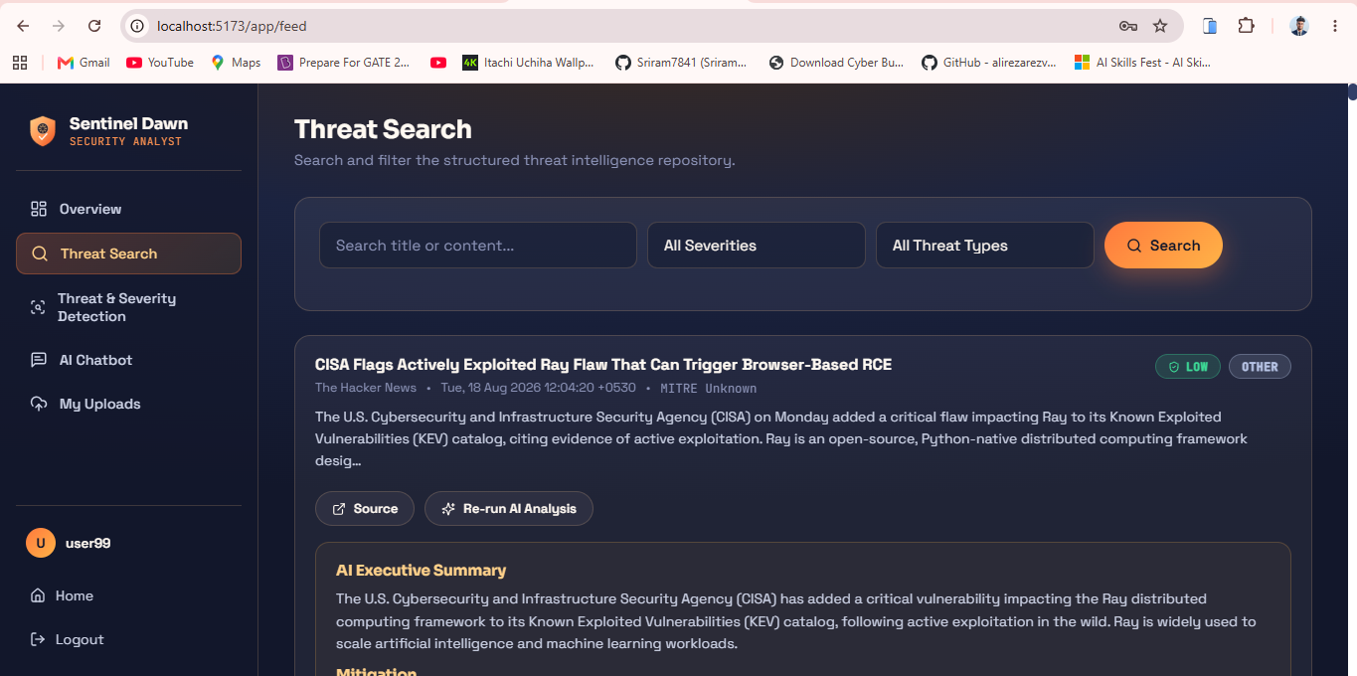
Fig 12: Threat Search Analysis - user module
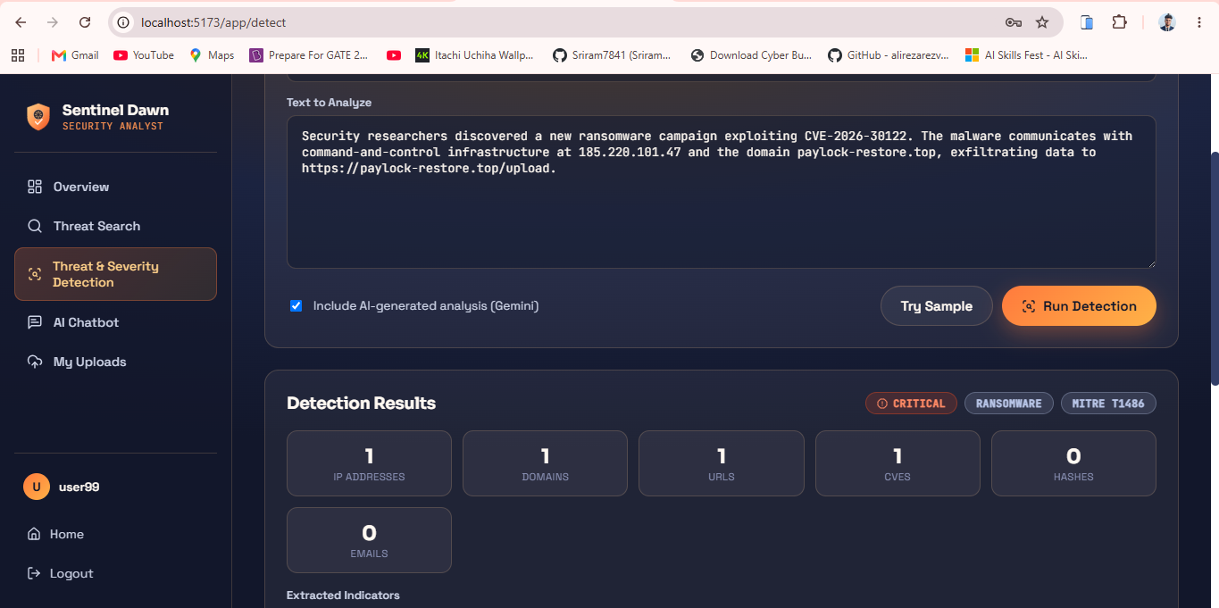
Fig 13: Threat detection - User module
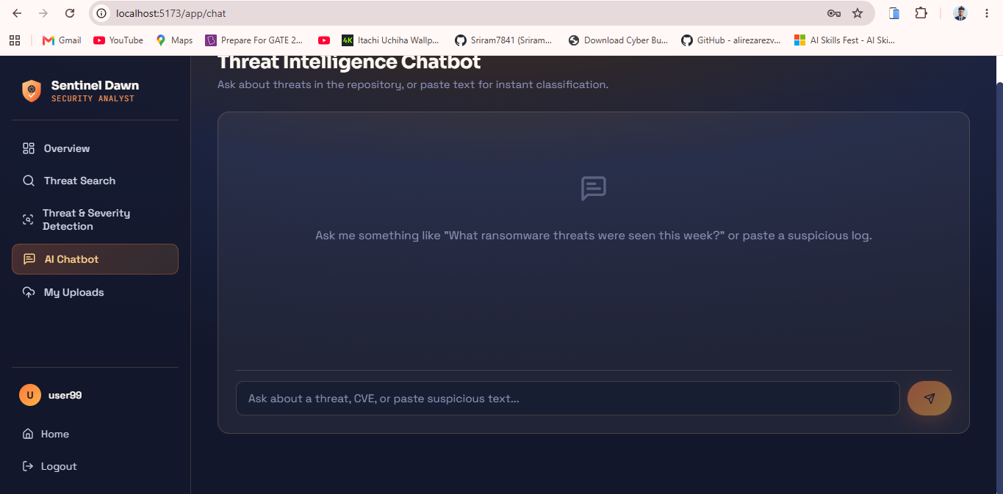
Fig 14 : Ai based chatbot

CHAPTER 11 : CONCLUSION AND FUTURE SCOPE

11.1 Conclusion
The proposed Cybersecurity Threat Intelligence Agent provides an integrated and AI-assisted approach for collecting, processing, analyzing, and presenting cybersecurity threat intelligence. The system addresses the limitations of fragmented and manually intensive threat-analysis processes by combining RSS-based threat intelligence collection, Indicator of Compromise (IOC) extraction, threat classification, severity assessment, MITRE ATT&CK mapping, and AI-assisted analysis within a single platform. The architecture uses React and Vite for the frontend, Python FastAPI for backend services, and SQLite3 for data storage. The system also provides separate User and Administrator functionalities, allowing users to perform threat searches, detection, AI chatbot interactions, and file uploads, while administrators can manage users, configure threat feeds and AI integration, initiate RSS ingestion, and review historical activity. The integration of the IOC engine and MITRE mapping provides structured information from otherwise unstructured threat reports, while Gemini-based analysis provides additional contextual interpretation. A rule-based fallback mechanism ensures that the core analysis workflow can remain functional when external AI services are unavailable. The system can also operate using seeded sample threat intelligence, making it suitable for demonstration and educational purposes. Overall, the proposed system demonstrates how automation and artificial intelligence can be combined with established cybersecurity analysis techniques to create a centralized, practical, and extensible Cyber Threat Intelligence platform.

11.2 Future Scope
The Cybersecurity Threat Intelligence Agent provides a foundation that can be extended with several advanced cybersecurity capabilities. One important area of future development is the integration of additional real-time threat intelligence sources beyond RSS feeds, including standardized CTI exchange mechanisms and other external intelligence platforms. The system could also be enhanced with advanced Natural Language Processing and machine-learning models for more accurate entity extraction, threat classification, IOC correlation, and threat-actor identification. Another potential enhancement is the development of a Cyber Threat Intelligence knowledge graph that connects IOCs, malware families, vulnerabilities, threat actors, campaigns, and MITRE ATT&CK techniques. This would enable deeper relationship analysis and cross-report correlation. The AI component could also be enhanced to provide automated incident summaries, threat reports, recommendations, and analyst assistance while incorporating stronger validation mechanisms for AI-generated results. Real-time alerting could be introduced so that analysts receive notifications when high-severity threats or important indicators are detected. The platform could further integrate with SIEM, SOAR, EDR, firewall, and intrusion-detection systems to support automated security operations. Advanced dashboards could provide trend analysis, threat timelines, geographic visualization, and risk prioritization. Finally, the system could be deployed as a scalable cloud-based service with stronger authentication, role-based access control, encrypted storage, and enterprise-level audit capabilities. These extensions would transform the current platform into a more comprehensive and scalable Cyber Threat Intelligence and Security Operations support system.

References
[1] N. Sun, M. Ding, J. Jiang, W. Xu, X. Mo, Y. Tai, and J. Zhang, “Cyber Threat Intelligence Mining for Proactive Cybersecurity Defense: A Survey and New Perspectives,” IEEE Communications Surveys & Tutorials, vol. 25, no. 3, pp. 1748–1774, 2023, doi: 10.1109/COMST.2023.3273282.
[2] V. Mavroeidis and S. Bromander, “Cyber Threat Intelligence Model: An Evaluation of Taxonomies, Sharing Standards, and Ontologies within Cyber Threat Intelligence,” in Proc. 2017 European Intelligence and Security Informatics Conference (EISIC), 2017, doi: 10.1109/EISIC.2017.20.
[3] V. Mavroeidis, R. Hohimer, T. Casey, and A. Jøsang, “Threat Actor Type Inference and Characterization within Cyber Threat Intelligence,” in Proc. IEEE International Conference on Intelligence and Security Informatics, 2021.
[4] P. Zhang, J. Ya, T. Liu, and J. Shi, “Mining Open-Source Cyber Threat Intelligence with Distant Supervision from the Web,” in Proc. 2021 IEEE Sixth International Conference on Data Science in Cyberspace (DSC), 2021, doi: 10.1109/DSC53577.2021.00018.
[5] S. Wolf, R. Foster, A. Mack, Z. Priest, J. Haile, and M. Borowczak, “Data Collection and Exploratory Analysis for Cyber Threat Intelligence Machine Learning Processes,” in Proc. 2022 9th Swiss Conference on Data Science (SDS), 2022, pp. 7–12, doi: 10.1109/SDS54800.2022.00009.
[6] M. Kadoguchi, S. Hayashi, M. Hashimoto, and A. Otsuka, “Exploring the Dark Web for Cyber Threat Intelligence using Machine Leaning,” in Proc. 2019 IEEE International Conference on Intelligence and Security Informatics (ISI), Shenzhen, China, 2019, pp. 200–202, doi: 10.1109/ISI.2019.8823360.
[7] E. Nunes, A. Diab, A. Gunn, E. Marin, V. Mishra, V. Paliath, J. Robertson, J. Shakarian, A. Thart, and P. Shakarian, “Darknet and Deepnet Mining for Proactive Cybersecurity Threat Intelligence,” in Proc. 2016 IEEE Conference on Intelligence and Security Informatics (ISI), Tucson, AZ, USA, 2016, pp. 7–12, doi: 10.1109/ISI.2016.7745435.
[8] P. I. Radoglou-Grammatikis, E. Kioseoglou, D. C. Asimopoulos, M. G. Siavvas, I. Nanos, T. Lagkas, V. Argyriou, K. E. Psannis, S. K. Goudos, and P. G. Sarigiannidis, “Surveying Cyber Threat Intelligence and Collaboration: A Concise Analysis of Current Landscape and Trends,” in Proc. 2023 IEEE International Conference on Cloud Computing Technology and Science (CloudCom), Naples, Italy, 2023, pp. 309–314, doi: 10.1109/CloudCom59040.2023.00057.
[9] F. Perrina, F. Marchiori, M. Conti, and N. V. Verde, “AGIR: Automating Cyber Threat Intelligence Reporting with Natural Language Generation,” in Proc. 2023 IEEE International Conference on Big Data (BigData), 2023, pp. 3053–3062, doi: 10.1109/BigData59044.2023.10386116.
[10] Y. Liu, X. Han, W. Zuo, H. Lv, and J. Guo, “CTI-JE: A Joint Extraction Framework of Entities and Relations in Unstructured Cyber Threat Intelligence,” in Proc. 27th International Conference on Computer Supported Cooperative Work in Design (CSCWD), Tianjin, China, 2024, pp. 2728–2733, doi: 10.1109/CSCWD61410.2024.10580210.
[11] H. Lv, X. Han, H. Cui, P. Wang, W. Zuo, and Z. Zhou, “Joint Extraction of Entities and Relationships from Cyber Threat Intelligence Based on Task-Specific Fourier Network,” in Proc. 2024 International Joint Conference on Neural Networks (IJCNN), Yokohama, Japan, 2024, pp. 1–8, doi: 10.1109/IJCNN60899.2024.10650942.
[12] X. Wang, M. Xiong, Y. Luo, N. Li, Z. Jiang, and Z. Xiong, “Joint Learning for Document-Level Threat Intelligence Relation Extraction and Coreference Resolution Based on GCN,” in Proc. 2020 IEEE 19th International Conference on Trust, Security and Privacy in Computing and Communications (TrustCom), 2020, pp. 584–591.
[13] A. Piplai, S. Mittal, A. Joshi, T. Finin, J. Holt, and R. Zak, “Creating Cybersecurity Knowledge Graphs From Malware After Action Reports,” IEEE Access, vol. 8, pp. 211691–211703, 2020, doi: 10.1109/ACCESS.2020.3039234.
[14] K. Shaukat, S. Luo, S. Chen, and D. Liu, “Cyber Threat Detection Using Machine Learning Techniques: A Performance Evaluation Perspective,” in Proc. IEEE International Conference on Cyber Warfare and Security, Islamabad, Pakistan, 2020, doi: 10.1109/ICCWS48432.2020.9292388.
[15] M. Ozkan-Okay, E. Akin, O. Aslan, S. Kosunalp, T. Iliev, I. Stoyanov, and I. Beloev, “A Comprehensive Survey: Evaluating the Efficiency of Artificial Intelligence and Machine Learning Techniques on Cyber Security Solutions,” IEEE Access, vol. 12, pp. 12229–12256, 2024, doi: 10.1109/ACCESS.2024.3355547.
[16] Z. Guan, L. Bian, J. Liu, and T. Shang, “When Machine Learning Meets Security Issues: A Survey,” in Proc. 2018 IEEE International Conference on Intelligence and Safety for Robotics (ISR), 2018, doi: 10.1109/IISR.2018.8535799.
[17] M. Kadoguchi, H. Kobayashi, S. Hayashi, A. Otsuka, and M. Hashimoto, “Deep Self-Supervised Clustering of the Dark Web for Cyber Threat Intelligence,” in Proc. 2020 IEEE International Conference on Intelligence and Security Informatics (ISI), Arlington, VA, USA, 2020, pp. 1–6, doi: 10.1109/ISI49825.2020.9280485.
[18] P. Radoglou-Grammatikis et al., “Surveying Cyber Threat Intelligence and Collaboration: A Concise Analysis of Current Landscape and Trends,” in Proc. 2023 IEEE International Conference on Cloud Computing Technology and Science (CloudCom), 2023, pp. 309–314, doi: 10.1109/CloudCom59040.2023.00057.

